Interactive Phonological Disorder Tool

Verónica Seoane

D10119992

**Contents**

Executive Summary 6

Introduction 7

1. Aims and Objectives 8

2. Background Research 9

2.1 Definition 9

2.2 Therapy 9

2.3 Target users 10

2.4 Results of research in the field 11

2.4.1 Consulting with domain experts 11

2.4.2 Survey Results 12

2.5 Competitive Analysis 18

3. Design 20

3.1 Project Description 20

3.2 Navigation Design 22

3.2.1 Interface 23

3.3 Designing Section One – Main Menu 23

3.4 Designing Section Two - “My Sound Words” 24

3.4.1 Progress of the design through the Project Development 25

3.5 Designing Section Three - the Matching Game 31

3.5.1 Progress of the design through the Project Development 31

4. Implementation 34

4.1 Navigation Code Structure 34

4.2 Section One – Main Menu 35

4.3 Section Two - “My Sound Words” 37

4.4 Section Three - the Matching Game 40

4.4.1 The levels 42

4.5 Video 51

4.5.1 Research 51

4.5.2 Filming and Editing Process 53

4.5.3 Code 58

4.6 Audio 61

4.6.1 Research 62

4.6.2 Process 62

4.6.3 Code 63

5. Website 68

6. User Test and Evaluation 71

6.1 User Testing by Specialists. 71

6.1.1 User Test and Suggestions 71

6.2 User testing by Parents of children with Phonological disorders / delay speech. 73

6.3 User testing by children 73

6.4. Bug Report 77

6.5. Heuristic Evaluation 80

7. Future development 82

8. Conclusion 84

Appendix List 85

Appendix 1 - Paper based exercises 85

Appendix 2 86

Appendix 3 – Competitive analysis – websites. 87

Appendix 3.1 87

Appendix 3.2 88

Appendix 3.3 89

Appendix 4 – Video and Sound Script 90

Appendix 4.1 Target Sounds 90

Appendix 4.1 Words 92

References 97

Bibliography 100

**Table of Figures**

Figure 1 Statistics – Percentage of children with phonological disorders 12

Figure 2 Statistics – Therapists’ point of view: Percentage of parents that do homework with their children 12

Figure 3 Statistics – Percentage of therapists that would use/recommend the website. 13

Figure 4 Statistics – Child age distribution 15

Figure 5 Statistics – parents that practice at home with their children 15

Figure 6 Statistics – Percentage of parents that would practice using a computer. 16

Figure 7 Statistics – Percentage of parents that have a computer and children that use the computer. 16

Figure 8 Statistics – Percentage of children using mouse or touchpad. 17

Figure 9 Statistics – Percentage of parents with internet connection. 17

Figure 10 Mock up – Example of positive reinforcement. 21

Figure 11 Program Navigation 22

Figure 12 The evolution of the main menu. 24

Figure 13 An example video. 25

Figure 14 First draft – Menu 26

Figure 15 Second Draft – Menu with individual buttons for each Target Sound. 26

Figure 16 Menu of Target Sounds presenting new theme. 27

Figure 17 Final design of the Target Sounds Main Menu. 27

Figure 18 Version 1 of the ‘Sound Words’ page. 28

Figure 19 Version 2 of the ‘Sound Words’ page. 29

Figure 20 Final Version of the ‘Sound Words’ page. 29

Figure 21 Final Version of the ‘Sound Words’ page, showing a video. 30

Figure 22 Example of Demo instructions for “My Sounds Words” Section 30

Figure 23 Versions 1 and 2 of the Games Menu. 31

Figure 24 Final version for the Games Menu 32

Figure 25 Original draft for the Matching Game 32

Figure 26 Final version for the Matching Game levels 33

Figure 27 Example of the Navigation Code Structure 34

Figure 28 Main Menu of the Application 35

Figure 29 Main Button for the Target Sounds in Main page of “My Sound Words” 37

Figure 30 Bar of Target Sounds 38

Figure 31 Matching Game Level One 42

Figure 32 Matching Game Level One 43

Figure 33 Matching Game Level Three 47

Figure 34 Matching Game Level Three 47

Figure 35 Matching Game Level Three 48

Figure 36. Speech therapy exercise – looking at the speech therapist when producing the sounds. 52

Figure 37 Example of video: Movement of the mouth and positioning of the lips. 52

Figure 38 Example of video: Movement of the mouth and positioning of the lips. 53

Figure 39 Example of video: Movement of the mouth and positioning of the lips. 53

Figure 40 Example of video: Movement of the mouth or positioning of the lips. 55

Figure 41 Example of Target Sound Video 55

Figure 42 Example of video editing: Movement of the mouth or positioning of the lips. 56

Figure 43 Example of video editing: Movement of the mouth or positioning of the lips. 56

Figure 44 Example of Video of Words- Listen to the instructions 56

Figure 45 Example of Video of Words- Look and listen to the Target Sound 57

Figure 46 Example of Video of Words- Listen to the word 57

Figure 47 Example of Video of Words- Listen to the word and look the movement of the mouth. 57

Figure 48 Example of how to get the video in “My Sound Words” pages 59

Figure 49 Example of Audio editing. 63

Figure 50 Example of the sound button in the game section 63

Figure 51: The publicly available site. 68

Figure 52: Results from the World Wide Web Consortium HTML5 validator. 69

Figure 53 - Newtownmountkennedy Community Playgroup 74

Figure 54 Aaron in “My Sound Words” section. 74

Figure 55 Luca (Age: 3 y.o.), playing the videos in the “My Sound Words” section. 75

Figure 56 Matthew (Age: 4 y.o.), starting the matching game in the level selection part. 75

Figure 57 Ava (Age: 3 y.o.), playing on level 1 of the Matching Game 76

Figure 58 Josh (Age: 3 y.o.), playing on level 3 of the Matching Game 76

Figure 59 Idea for a second game. 83

# Executive Summary

The purpose of this project is to provide a website that children with phonological disorders or speech delay can use in a fun and interactive way as an extra tool to supplement the exercises given by their speech therapist.

Following consultation with speech therapists and parents, it became clear that having this kind of website available at their home would be highly beneficial for these children.

The website contains both games and videos. The games are carefully constructed so that the children can meet each target without getting frustrated. The videos are a fundamental part of the project as they help the children by not only outputting the sound of the word (pronunciation) but also how to form the word (articulation).

The following technologies were used in the development of the website and application: HTML5, CSS, JavaScript, Adobe Flash Professional CS5, Adobe Premier CS5 and Adobe Photoshop CS5.

Testing and evaluation of the project was carried out throughout all phases of the project and a final testing was made with children at Newtownmountkennedy Community Playgroup in Wicklow.

The website is publicly available at: http://www.SpeakingIsFun.com

# Introduction

The purpose of this report is to present the project **“Speaking is Fun”**, a website that children with phonological disorders can use in a fun and interactive way as an extra tool to supplement the exercises given by their speech therapist.

* In chapter 1 and 2, the aims and objectives of the project and the background research will be explained.
* In chapter 3, the design of the project is described in detail.
* In chapter 4, the implementation is explained.
* In chapter 5, the information about the website is covered.
* Chapter 6 covers user test results and evaluation.
* Chapter 7 describes the future work for this project.

In general, this report will introduce and describe a website with games and videos dedicated to children with phonological disorders.

# Aims and Objectives

The main aim of this project is to create a website that can be used by children with phonological disorders or speech delay as a helpful tool at hometo reinforce or supplement the exercises given by their speech therapist.

The objectives of this project are:

1. To produce a tool easy to use after therapy, in this case a website that the child can use to practice what he/she learnt in therapy.
2. To integrate games that can help the child on a daily basis to practice at home what he/she was taught at the therapy sessions.
3. To include sound and video to aid in conveying the target sound that they are practising and how the sound is produced.

# Background Research

This project, as mentioned, intends to create a helpful tool for children with phonological disorders.

## 2.1 Definition

“Phonological Processing Disorders – ‘Phonology’ is the sound system of language. The phonology of language tells us how sounds fit together in words. Children who have phonological processing disorders have not learned the rules for how sounds fit together to make words, and use certain processes to simplify words.” [1]

“A person with phonological disorder may not have developed adequate mental representations of the sound system of the language that surrounds him or her.” [2]

5% of children have the most common disability (Phonological Disorder), meaning that at least 2 children in a standard class may have this disorder.

## 2.2 Therapy

Children with Phonological disorders use incorrect speech patterns by making errors on sound patterns or sound blend [3]. Children with these disorders are at a very high risk of later reading and learning disabilities, and should be treated with intensive speech therapy as soon as they are diagnosed, as early as age 3 [4].

There are different ways to help children with phonological disorders during therapy. The most common technique used to address their difficulties is sound based.

“Therapy for phonological processes involves making the child more aware of the correct sound patterns (rules) and drilling the new patterns*. Awareness is frequently achieved through what is referred to as “auditory bombardment”; using an amplifier and headphones, the therapist will repeatedly say words using the correct patterns*.” [5]

Although it is possible to apply these techniques (using amplifier, headphones, etc.), it may be the case that not all therapists have these kind of instruments. In most therapy clinics or therapy practices, the sounds are produced orally by the therapists themselves.

It is also common that therapists, as an additional tool, use paper based examples to show what the sounds or formed words represent (see Appendix1).

It is important that, not only does the child do the tasks given in therapy, but also practices at home. At home, the tools to practice the exercises tend to be very basic, paper based and words reproduced by parents.

## 2.3 Target users

This website is aimed at:

1. Children with Phonological disorders / delay speech.
   1. The group age is mainly for children between 3 – 6 years old.
   2. Children, that do not know how to use the mouse or computer, will need to be supervised and helped by parents.
   3. Children, that do not know how to read, will need to be supervised and helped by parents.
   4. The goal is to reach these children and give them an extra tool for them to practice their therapy exercises at home in a fun and interactive way.
2. Parents of children with Phonological disorders / delay speech.
   1. The goal is to help the parents, providing a tool that can facilitate the practice of therapy exercises at home.
   2. This website will eliminate or reduce the need to use paper-based examples. This will help the parents from having to create these paper examples themselves.
   3. It will allow the parents to monitor the progress of their children.

## 2.4 Results of research in the field

### 2.4.1 Consulting with domain experts

* There were multiple meetings with the Head of the Clinical Speech & Language Studies Department from the School of Linguistic, Speech and Communication Sciences of Trinity College regarding the project. The meetings were very productive and she provided material such as books and examples of the exercises she practices with the children in her workshop. She mentioned that the project was a good idea because parents often ask for a web-based tool they could use at home, for them to practice with their children some of the exercises they are given in therapy.
* There were also meetings with Barbara Hallahan MFA, MS, CCC-SLP, Speech and Language Pathologist (see CV in Appendix 2). She expressed interest in the project and offered her expertise should it be needed during the development of the project. She also offered to contact some of her patients (parents and children) and ask them if they would help if any necessary testing was required.

### 2.4.2 Survey Results

According to the initial research (surveys sent by email to therapist and parents with children with phonological or speech disorder):

1. **Speech therapists**
2. This graphic shows that in general, there is a big group of children with Phonological Disorders.

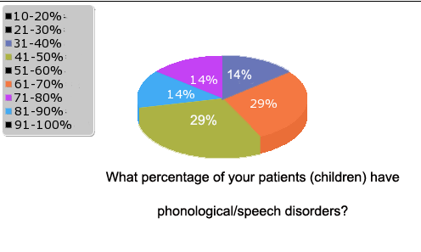

Figure 1 Statistics – Percentage of children with phonological disorders

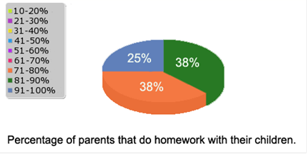

Figure 2 Statistics – Therapists’ point of view: Percentage of parents that do homework with their children

1. In the following graphic, it is clearly shown, after consulting with a number of speech therapists, that this type of website would be useful. It could be a tool parents could access easily and potentially aid their children.

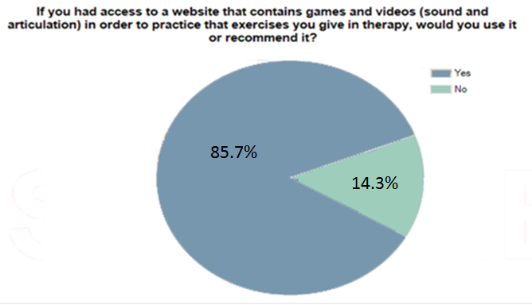

Figure 3 Statistics – Percentage of therapists that would use/recommend the website.

However, the following answers from the therapists show us that most of the homework the children do is paper based.

What kind of speech sound disorder homework do you send home?

Therapists answered:

* Auditory bombardment exercises, phonological worksheets, information on visual cueing, modelling and recasting, pictures of target sound words.
* Paper-based. E.g. pictures, puzzles etc. focused on the particular speech sound; drill articulation work.
* Black Sheep Press activity sheets, target sound pictures, Nuffield Dyspraxia Programme sheets, ELR Resources (computer based activities).
* Each child has a scrap book with games or exercises appropriate to the sound being worked on that is revised at home each day.
* Printed material, single pictures on cards, sheets of pictures containing target sounds, printed word lists, printed activities with target sounds, printed instructions for oral movement exercises, objects created during session that contain target words.
* Minimal pair activities (picture based).

1. Extra comments made by the therapists:

“There is a definite need for games and homework computer practice in speech therapy and speech sound disorder work, especially if it can track the child's progress. And vocabulary that is used in Ireland, not too American or British.”

“Most families do ask me about web-based online resources to supplement the therapy.”

1. **Parents of children with phonologic or speech disorders**

Some therapist sent this survey to their patients; some other surveys were answered by parents contacted through online parenting magazines and support groups for parents of children with phonological disorders.

These are some of the results:

* 1. The majority of the children in this group fluctuate between 3 and 6 years old.
  2. 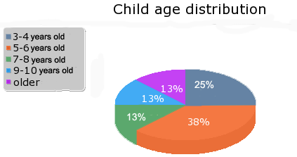

Figure 4 Statistics – Child age distribution

* 1. Parents are used to practicing with their children. They supervise and control the progress of their children.

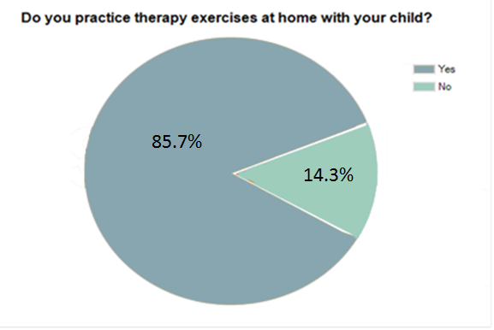

Figure 5 Statistics – parents that practice at home with their children

* 1. Parents would also be inclined to practice with their child using a web- based program.

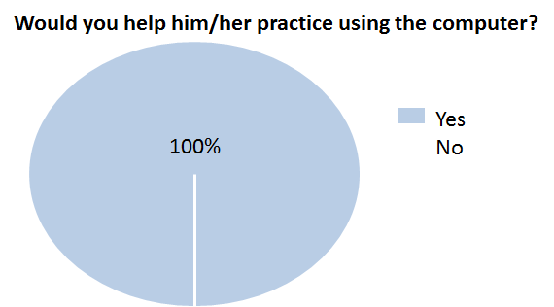

Figure 6 Statistics – Percentage of parents that would practice using a computer.

* 1. This following graphics show that the majority of children under 6 years old are comfortable using the computer. These results are backed up by other independent studies [6].

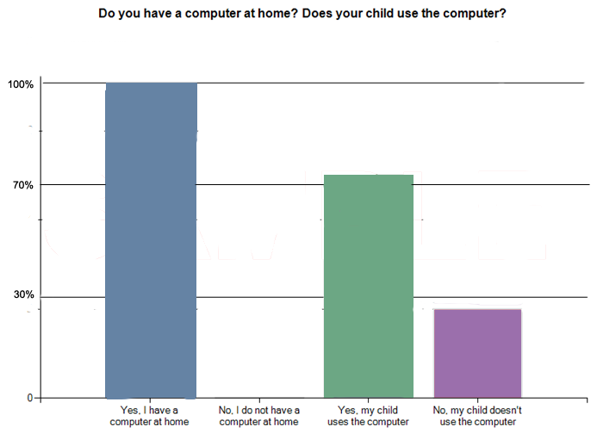

Figure 7 Statistics – Percentage of parents that have a computer and children that use the computer.

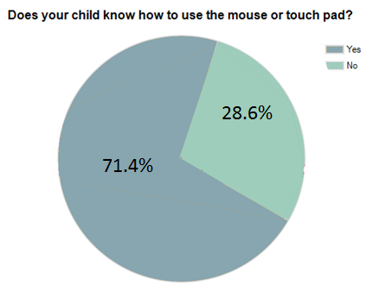

Figure 8 Statistics – Percentage of children using mouse or touchpad.

* 1. Most parents have easy access to the Internet and are able to watch videos on their computers.

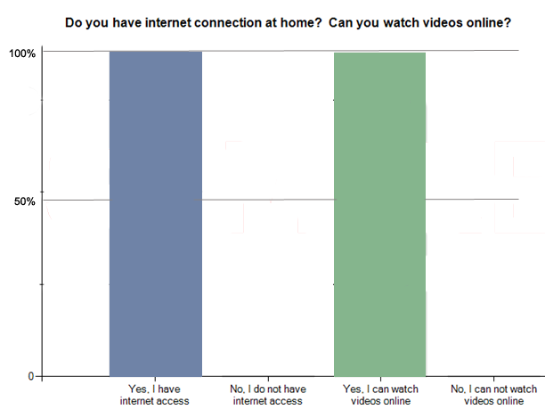

Figure 9 Statistics – Percentage of parents with internet connection.

* 1. Another question answered by parents:

Would you prefer your child doing his speech therapy homework using a website instead of with you? If so, why? Would you like a website for him to practice on that includes games and videos?

They provided the following answers:

* He's at an age where he does like to do things independently
* Yes but very simple games
* Yes, it would be good to have an alternative as an additional support for when I am busy. More therapy input is always good.
* We'd be open to anything that would help him.

All these results justify the decision to develop a fun and interactive website specifically dedicated for children with phonological disorders.

## 2.5 Competitive Analysis

Having spoken with a therapist at the Department of Clinical Speech & Language Studies at Trinity College, it was commented that it is very common that parents ask for a website, as an additional tool, to provide exercises for their children in order to practice what they have learnt in therapy.

Taking this into consideration, it was found that there are many different websites promoting phonological awareness. However, the vast majority are based on helping children to improve their speech and to promote success in early reading. Very few concentrate on helping children that are receiving therapy to overcome their phonological disorder. As a result, the research was focussed on this area.

Research suggested that the number of websites dedicated to phonological disorders with exercises and advice is considerable. However, the majority of these websites offer this advice in a written way, explaining how to make certain games or implement a particular exercise. They do not provide a practical, interactive approach to them (see Appendix 3.1).

There are a few other sites that provide examples of sounds and their use in words, providing sounds and visuals, but they do not offer the interactive factor (see Appendix 3.2.).

Finally, there are a very limited number of websites, which are very difficult to find online, that provide interaction while practicing sound exercises (see Appendix 3.3).

In conclusion, there are only a very limited number of interactive websites dedicated to practicing exercises with children with phonological disorder.

# Design

## 3.1 Project Description

As previously mentioned, the intention of this project is to create a website that can be used by children and can be a helpful tool at hometo reinforce the exercises given by their speech therapist.

This website consists of two main focal points:

1. Games:

* Games that will help the child to practice his/her exercises in a fun way.
* Games that will be focus on specific target sounds or phonemes that are known to cause the most problems.
* Games that will be interactive.

The matching game in this project comprises exercises to reinforce fronting[1] problems.

The games are designed to be inspiring and encouraging. If the child is right in his answers, he will get a positive response for it. If he is wrong in his answers, he will get a motivational message to try again. The aim is to avoid frustrating the child by being too negative.



Figure 10 Mock up – Example of positive reinforcement.

1. Videos:

* Videos that can be of extra help to the child when having problems recognizing a sound.
* Videos that show not only the sound but the movement of the mouth or positioning of the lips.
* Videos that allow the child to get clues when he/she has made mistakes in an exercise.
* Videos that will help the child visualize and recognize the sounds at the same time.

Most of the games, the videos, and all the other parts of the project use the technique called “Auditory bombardment[2]”.

## 3.2 Navigation Design

Main Menu

Game

My Sound Words

Main

Menu

Sounds

-Target Sound Pages-

B P M

D T L

N F V

S Z SH

J CH R

W Y K

C G H

Matching

Game

-Levels Menu-

Level One

Level Two

Level Three

Figure 11 Program Navigation

### 3.2.1 Interface

It is important to emphasise that this application, although it is directed to children, needs to be used under parent supervision to maximize the improvement of the child.

The main points regarding the interface of this application are:

* The theme:

The development and design of the application went through different changes. In the end, it was decided to have a theme that children could relate with in a fun way.

The design of the application looks like a notebook. Since this is meant to be a homework tool, it seems appropriate.

* The user needs to use a mouse or touchpad.
* The games contain draggable images.
* All images were taken from free clipart websites [10]

## 3.3 Designing Section One – Main Menu

The main menu displays the 2 principal sections of this program. The **“My Sound Words”** section (originally called “My Vocabulary”) and the **“Let’s Practice”** section that contains the games.

The main menu had only a couple of changes during development, based on the changes made on the other sections.

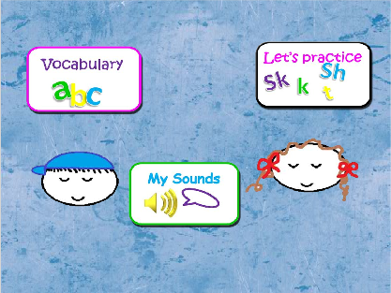

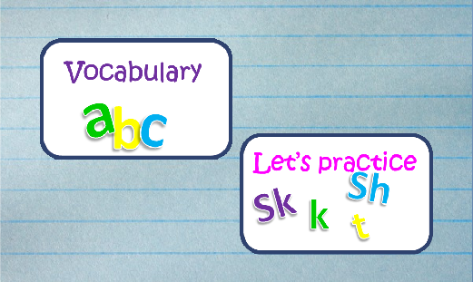 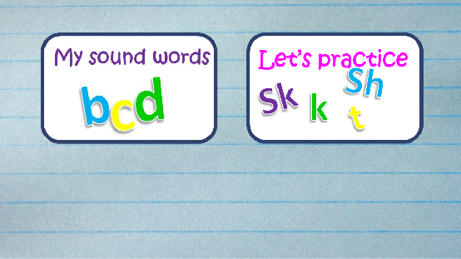

Figure 12 The evolution of the main menu.

## 3.4 Designing Section Two - “My Sound Words”

This section contains the list of all target sounds in alphabetical order. In here the children can learn the words, identify the sound that corresponds to the word and the matching image.

This section contains a menu that allows the child to select the target sound they wish to practice. Once the desired sound is selected, the desired sound page appears.

The page that corresponds to the sound contains a list of words and their corresponding image.

In order to learn the sound of the words and the correct pronunciation, the user can click on the image and a video will appear showing the correct pronunciation and how to form the words.

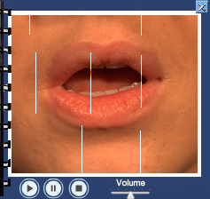

Figure 13 An example video.

### 3.4.1 Progress of the design through the Project Development

1. Main Page

The main idea was to present on the first page of this section the Sounds (letters) the child wanted to study and allow the child to click on them. It was made in a fun way and to be visually agreeable.

The first version presented buttons with the letters in groups:

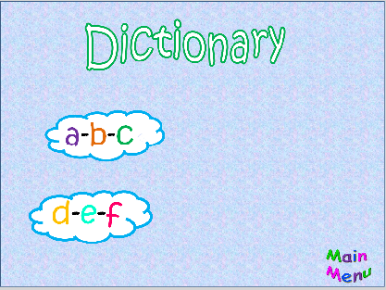

Figure 14 First draft – Menu

After the first assessment from project consultant, speech and language pathologist Barbara Hallahan, it was suggested that each sound should be presented in an individual button to make it easy for a child to choose a target sound to practice.

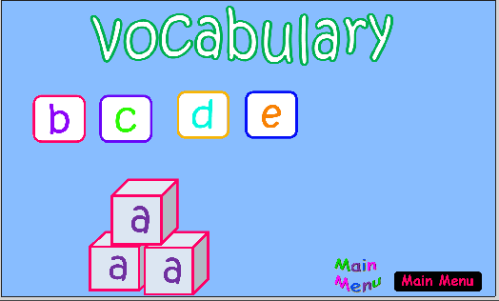

Figure 15 Second Draft – Menu with individual buttons for each Target Sound.

Once the theme was selected, a design for the main page of the ‘My Sound Words’ section was created:

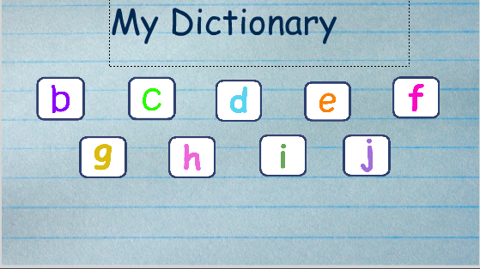

Figure 16 Menu of Target Sounds presenting new theme.

At the beginning the title of this section was “My dictionary”, but it was changed to “My sound Words” as it is based on phonetic sounds and not on the alphabet and words per se.

This was the final layout for the My Sound Words main menu:

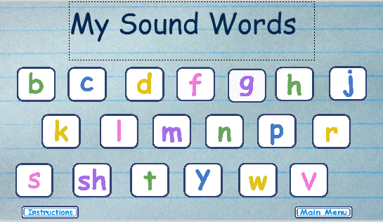

Figure 17 Final design of the Target Sounds Main Menu.

1. Sounds Pages

Each target sound has it corresponding page. There are 21 pages, one for each target sound:

/B/, /P/, /M/,/D/, /T/,/L/, /N/,/F/, /V/,/S/, /Z/,/SH/, /J/,/CH/, /R/,/W/, /Y/,/K/, /C/,/G/, /H/

Each page contains a list of images and the matching written word. The idea of these pages is to present a list of words/images regarding the sound the child wants to study. What it is important in this segment is it not only has the written word and image but also access to corresponding videos where the user can see the movement of the mouth when generating the sound and hear the pronunciation.

In the first and second drafts, it is possible to see the image, the word and the buttons that were assigned to access either the video or sound. The only difference is in the design of the page.

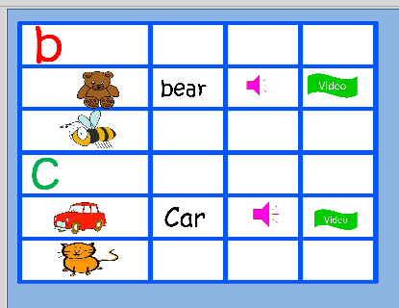

Figure 18 Version 1 of the ‘Sound Words’ page.

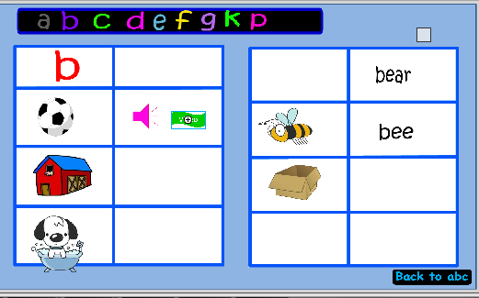

Figure 19 Version 2 of the ‘Sound Words’ page.

It was decided than instead of having two buttons, one for sound and one for video, the image itself would be a button and would open a window with the video and sound when clicked.

A later addition to this design was the letter bar that allows the user to navigate from sound page to sound page without the need to go back to the main sound menu.

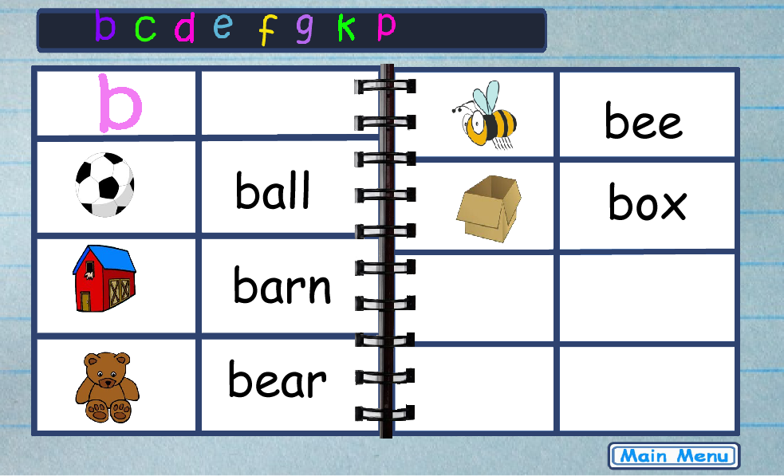

Figure 20 Final Version of the ‘Sound Words’ page.

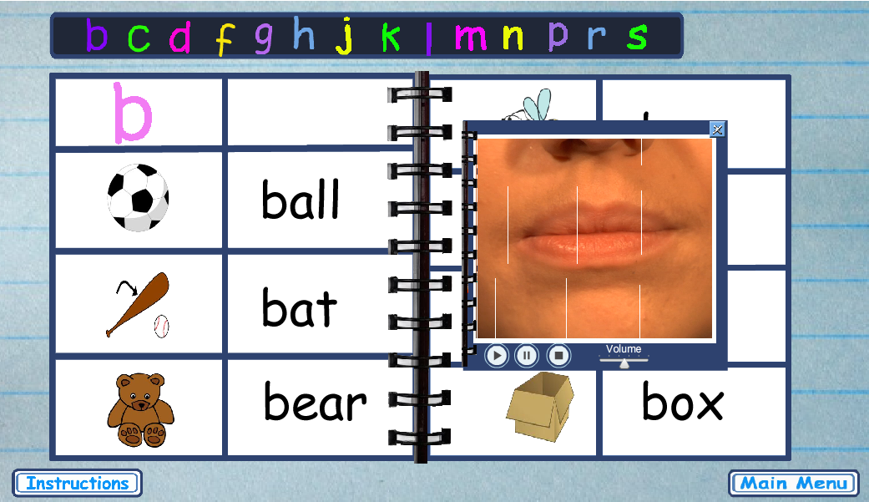

Figure 21 Final Version of the ‘Sound Words’ page, showing a video.

To complement this section, an instructions button was added, this displays a demo of what the user needs to do, including verbal instructions.

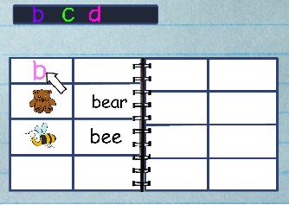 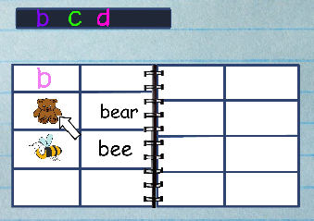

Figure 22 Example of Demo instructions for “My Sounds Words” Section

## 3.5 Designing Section Three - the Matching Game

This section had many changes during its development.

The plan for the games section was to have 2 different games, but after further consideration and specialist consult, it was decided to initially have one game with different levels that would progress in difficulty. This would help the children to gradually improve their speech and knowledge of the target sounds and words.

### 3.5.1 Progress of the design through the Project Development

1. Game Menu and Levels

* This menu was originally meant to contain the buttons that would link to the different games:

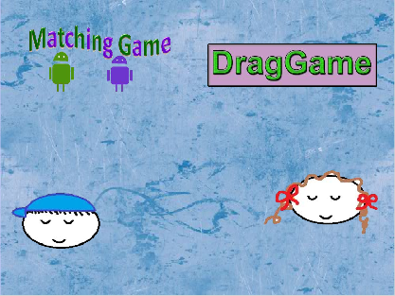 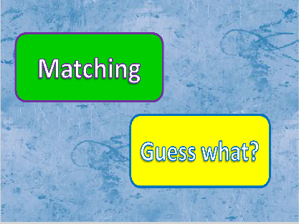

Figure 23 Versions 1 and 2 of the Games Menu.

Since the decision of making one game was taken, this menu was removed and was integrated as a dynamic button in the Main Menu of the program:

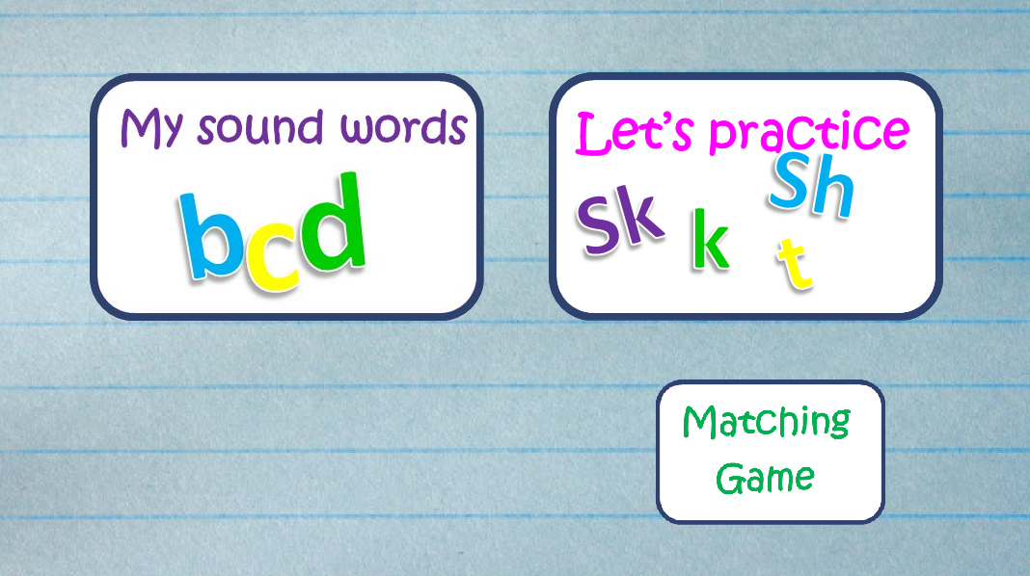

Figure 24 Final version for the Games Menu

Regarding the levels, it was initially decided to have 2 levels for the first game:

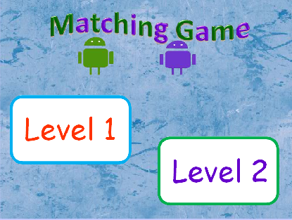

Figure 25 Original draft for the Matching Game

But the final version had four levels and it was decided to use circles instead of rectangles for the links to the levels. This made it look a more playful.

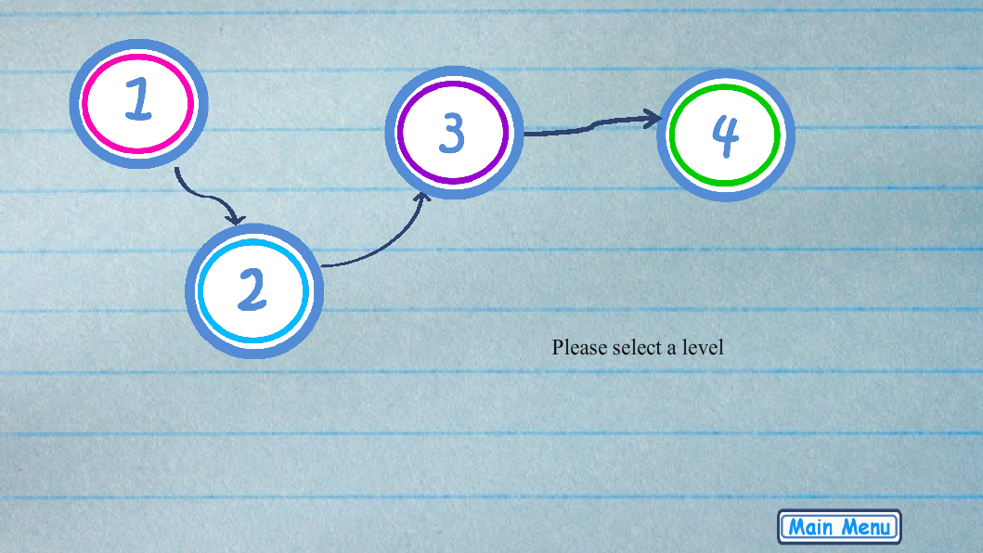

Figure 26 Final version for the Matching Game levels

# Implementation

## 4.1 Navigation Code Structure

The application was developed in Adobe Flash Professional CS5.

It is comprised of 4 SWF[3] files:

1. MainMenu.SWF
2. MySoundsWords.SWF
3. matchingGame.SWF
4. myVideoWindows.SWF

Main Menu

Matching

Game

My Sound Words

Video Windows

External Video Files

**1**Level Four

**2**

**3**

**4**

Figure 27 Example of the Navigation Code Structure

## 4.2 Section One – Main Menu

The Main Menu SWF file consists of 2 main buttons. One button, when clicked, directs the children to the ‘My Sounds Words’ section. The other button, on MouseOver, displays a smaller button called ‘Matching Game’ that links to the Matching Game section.



Figure 28 Main Menu of the Application

1. //--------------------- MAIN MENU ----------
2. //--------------SECTION ONE-- OPEN DICTIONARY SWF -----
3. dictionary_btn.addEventListener(MouseEvent.CLICK, goToDictionary);
4. **function** goToDictionary(event:MouseEvent):**void**
5. {
6. **var** loadingSwf:Loader = **new** Loader();
7. loadingSwf.load(**new** URLRequest("../flash/MySoundsWords.swf"));
8. addChild(loadingSwf);
9. }
10. //---------END -----SECTION ONE----OPEN DICTIONARY SWF ---

13. //---------SECTION TWO ---- OPTIONS FOR MENU GAMES -
14. //----game options ---
15. **var** matchGame:MovieClip = **new** matchMenu  ;
16. matchGame.name = "matchMenu";
17. //----- show the game options---------
18. gamesMenu.addEventListener(MouseEvent.CLICK, goToGamesOptions);
19. **function** goToGamesOptions(event:MouseEvent):**void**
20. {
21. addChild(matchGame);
22. matchGame.x = 800;
23. matchGame.y = 470;
24. /*addChild(guessGame);
25. guessGame.x = 880;
26. guessGame.y = 470;*/
27. }
28. //----- Hide game options -------
29. gamesMenu.addEventListener(MouseEvent.MOUSE_OVER , goToGamesOptionsRemove);
30. **function** goToGamesOptionsRemove(event:MouseEvent):**void**
31. {
32. removeChild(matchGame);
33. }
34. //------- GAMES SWF -----------
35. **var** loaderMatchLevel01:Loader = **new** Loader();
37. matchGame.addEventListener(MouseEvent.CLICK, goToMatchMenu);
38. **function** goToMatchMenu(event:MouseEvent):**void**
39. {
40. loaderMatchLevel01.load(**new** URLRequest("../flash/PREFINAL-MatchingGame001.swf"));
41. addChild(loaderMatchLevel01);
42. }

## 4.3 Section Two - “My Sound Words”

The most important features in the MySoundWords.SWF file are the menu of Target Sounds, the individual Target Sound pages and the bar with all the target sound letters that is shown on all pages.

* In the Target Sounds menu, each individual target Sound button (e.g. ‘b’, ‘c’ etc.) takes the user to the corresponding Sound page:

Example:

//---------GO to ABC pages - from Main Btns----------------

mainB_btn.addEventListener(MouseEvent.CLICK, main_gotoB);

**function** main_gotoB (event:MouseEvent): **void**

{

    gotoAndStop("letterB");

 addAbcBarLetters(abcBarGroup);

add_B_Images(BImagesGroup);

}



Figure 29 Main Button for the Target Sounds in Main page of “My Sound Words”

The bar with all the target sound letters is shown in all the pages.



Figure 30 Bar of Target Sounds

-All the letters are added dynamically:

1. //----- SECTION TWO ------ARRAY OF ABCS BAR LETTERS----
2. //Array ABC Bar//
3. **var** abcLetters:Array = **new** Array();
5. **var** Bbtn:MovieClip = **new** B_btn  ;
6. Bbtn.name = "B_btn";
7. .
8. .
9. **var** Sbtn:MovieClip = **new** S_btn  ;
10. Sbtn.name = "S_btn";
11. abcLetters.push(Bbtn, Cbtn, Dbtn,Fbtn, Gbtn, Hbtn, Jbtn ,Kbtn, Lbtn,Mbtn,Nbtn, Pbtn, Rbtn,Sbtn);
12. // Definition of Var of Abc Letter Position
13. **var** abcBarGroup;
14. **var** imagePosition = 140;
15. //function: Adds all abc Bar letters
16. **function** addAbcBarLetters(event:MouseEvent):**void**
17. {
18. **for** (**var** i:uint= 0; i < abcLetters.length; i++)
19. {
20. abcBarGroup = abcLetters[i];
21. addChild(abcBarGroup);
22. abcBarGroup.x = imagePosition;
23. abcBarGroup.y = 45;
24. imagePosition = abcBarGroup.x + 50;
25. }
26. }
27. //----- END--------SECTION TWO ------ARRAY OF ABCS BAR

* In the Target Sound pages all images are added dynamically.

Example:

//-----SECTION ONE----adding word Images to each letter page--;

//ALL WORD_IMAGES DEFINITION

**var** B_ImagesGroup:Array = **new** Array();

**var** C_ImagesGroup:Array = **new** Array();

.

.

//-*-*-* B *-*-*

**var** ball_Image:MovieClip = **new** ballImage  ;

ball_Image.name = "ballImage";

**var** bat_Image:MovieClip = **new** batImage  ;

bat_Image.name = "batImage";

**var** bell_Image:MovieClip = **new** bellImage  ;

bell_Image.name = "bellImage";

**var** bear_Image:MovieClip = **new** bearImage  ;

bear_Image.name = "bearImage";

.

.

B_ImagesGroup.push(ball_Image, bat_Image, bear_Image, bee_Image,bell_Image,big_Image, box_Image);

//function: Adds all B images

**function** add_B_Images(arr:Array):**void**

{

**for** (**var** i:uint= 0; i < B_ImagesGroup.length; i++)

  {

    addChild(B_ImagesGroup[i]);

    BImagesGroup = B_ImagesGroup[i];

**if** (i < 3)

    {

      BImagesGroup.y = BgroupPositionY1;

      BgroupPositionY1 = BImagesGroup.y + 130;

      BImagesGroup.x = 190;

    }

**else**

    {

      BImagesGroup.y = BgroupPositionY2;

      BgroupPositionY2 = BImagesGroup.y + 110;

      BImagesGroup.x = 670;

    }

  }

  BgroupPositionY1 = valueY1;

  BgroupPositionY2 = valueY2;

}

## 4.4 Section Three - the Matching Game

The matching game is set to have four or five levels, each one with the specific purpose to aid the speech progress of the child. This concept was decided upon in conjunction with project consultant Speech Pathologist Barbara Hallahan.

This game is based on a Drag and Drop game [9].

All the levels use similar code with slight differences for each level:

1. //Definition global variables used in drag&drop
2. **var** objectoriginalX:Number;
3. **var** objectoriginalY:Number;
5. //---- PickUp Object Function----------
6. **function** pickupObject(event:MouseEvent):**void**
7. {
8. event.target.startDrag(**true**);
9. event.target.parent.addChild(event.target);
10. objectoriginalX = event.target.x;
11. objectoriginalY = event.target.y;
12. }
14. //---- end--------PickUp Object Function----------
15. //-----Drop Object Function-------------------------
16. **var** indexScoreStar=0;
17. **function** dropObject(event:MouseEvent):**void**
18. {
19. event.target.stopDrag();
20. response_mc.visible = **true**;
21. //Retrieve the target for the selected image.;
22. **var** matchingTargetName:String = "target" + event.target.name;
23. **var** matchingTarget:DisplayObject = getChildByName(matchingTargetName);
24. //  Pick & drop object on target ---- responses ---
25. **if** (event.target.dropTarget != **null** && event.target.dropTarget.parent == matchingTarget)
26. {   //IF - object on correct target
27. event.target.removeEventListener(MouseEvent.MOUSE_DOWN, pickupObject);
28. event.target.removeEventListener(MouseEvent.MOUSE_UP, dropObject);
29. event.target.buttonMode = **false**;
30. event.target.x = matchingTarget.x;
31. event.target.y = matchingTarget.y;
32. points++;
33. pointsField.text = String(points) + " points";
34. response_txt.text = "Correct!";
35. response_mc.gotoAndStop(2);
36. positiveL03.play();
37. }
38. **else**
39. {
40. //ELSE - object on incorrect target
41. event.target.x = objectoriginalX;
42. event.target.y = objectoriginalY;
43. response_txt.text = "Try again";
44. response_mc.gotoAndStop(3);
45. negativeL03.play();
46. }

### 4.4.1 The levels

**Level One –**

* This level introduces all the words the child is going to use but using a field of 3 words that each starts with a different sound.
* The purpose is for the child to understand what he/she needs to do and identify the different sounds. It makes sure the child knows the words that go with the pictures.
* This level doesn’t have video clues, it only has sound clues. This is in order to make the first level simple for the children. It also prevents the user from incorrectly repeating the words without the supervision of the therapist.
* In this level the child has to listen to the sound of the unknown image and, when they understand the word, they can drag the correct image to the empty box. If the child has problems identifying the images, they can always click on the clue buttons and the sound of the clicked image will be played. This way the child can compare it with the original sound.

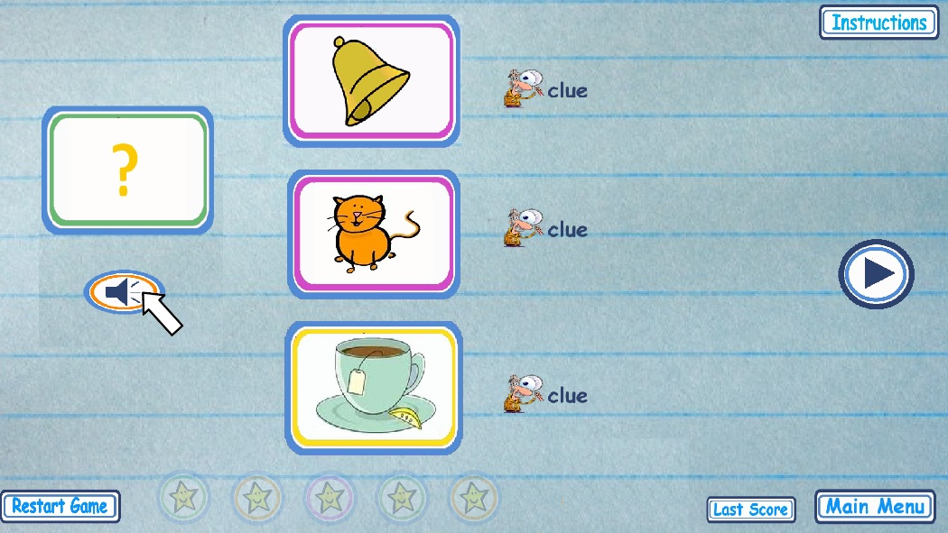

Figure 31 Matching Game Level One

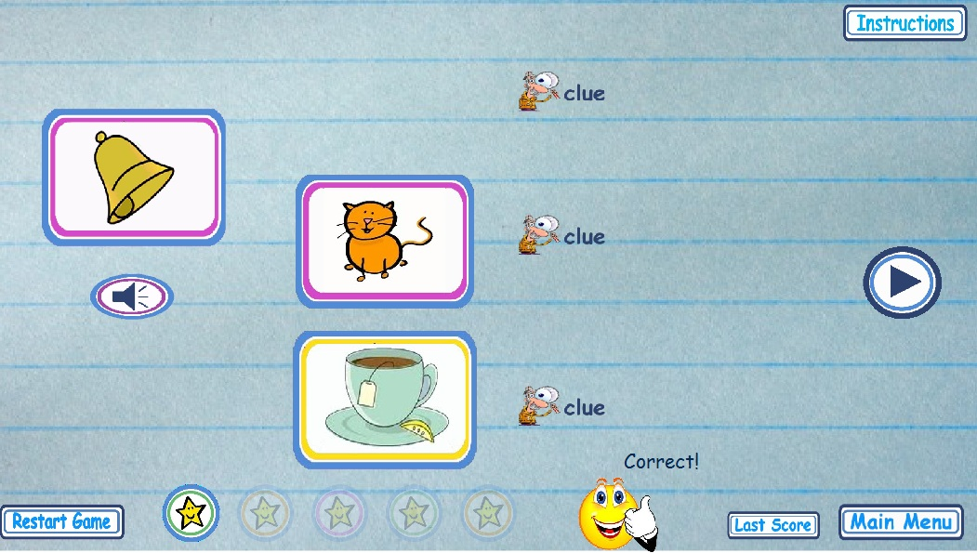

Figure 32 Matching Game Level One

In this level, it is important to know the following facts regarding the implementation:

* All images (objects and target Squares) are added dynamically.
* The images are random from a group of images, so the child won’t always have the same images.
* The target image is also random so even if the user sees the same images as before, the target image might be different.
* The sound buttons match the random target image so the hints will always be accurate.

Example:

1. **var** numberOf_SETSL01=imagesGroup_L01[index_SetL01].length;
2. **for** (**var** Index_objectInSetL01:uint= 0;Index_objectInSetL01 < 3 ; Index_objectInSetL01++)
3. {   //Definition of Private Variables
4. **var** image_L01 = imagesGroup_L01[index_SetL01][Index_objectInSetL01];

1. // Adding Images - Sets per page ---
2. addChild(imagesGroup_L01[index_SetL01][Index_objectInSetL01]);
3. //ASSIGNING POSITION TO IMAGES ON STAGE
4. image_L01.x = 430;
5. image_L01.y = imagePositionL01;
6. imagePositionL01 = image_L01.y + 170;
8. //Getting the names of the 3 Images and getting their Target name
9. **var** image1=imagesGroup_L01[index_SetL01] [0]
10. **var** image2=imagesGroup_L01[index_SetL01] [1]
11. **var** image3=imagesGroup_L01[index_SetL01] [2]
12. **var** myTargetName1 = "target" + image1.name as String;
13. **var** myTargetName2 ="target" + image2.name as String;
14. **var** myTargetName3 ="target" + image3.name as String;
16. //Assigning the Class name to the targets
17. **var** myTarget1=getDefinitionByName(myTargetName1) as Class;
18. **var** myTarget2=getDefinitionByName(myTargetName2) as Class;
19. **var** myTarget3=getDefinitionByName(myTargetName3) as Class
21. //Definition of the targets
22. **var** Thetarget1:MovieClip = **new** myTarget1;
23. Thetarget1.name = myTargetName1;
24. **var** Thetarget2:MovieClip = **new** myTarget2;
25. Thetarget2.name = myTargetName2;
26. **var** Thetarget3:MovieClip = **new** myTarget3;
27. Thetarget3.name = myTargetName3;
29. //Creating an Array of Targets
30. **var** myTargetArray:Array = [Thetarget1,Thetarget2,Thetarget3]
31. // Removing Images from stage - Sets per page ---
32. **if** (index_SetL01 > 0)
33. {
34. **if** (stage.contains(imagesGroup_L01[index_SetL01][Index_objectInSetL01]))
35. {
36. removeChild(imagesGroup_L01[index_SetL01-1][Index_objectInSetL01]);
37. }
38. }
39. }
40. // Randomizing the TargetArray
41. myTargetArray.sort
42. (**function** ()
43. {
44. **return** Math.round(Math.random());
45. });
46. //Selecting only ONE target from the Array
47. **var** myTarget=myTargetArray [1];
48. addChild(myTarget)
49. myTarget.x = 160;
50. myTarget.y = 200
52. // Selecting 1 target and looking for its matching sound btn
53. targetName =  myTarget.name;
54. mySoundName =  "Sound" + targetName;
55. **var** soundToPlay="../sound/"+mySoundName+".mp3" as String;
56. **var** RequestSound:URLRequest = **new** URLRequest(soundToPlay);
57. **var** mySound:Sound=**new** Sound();
58. mySound.load(RequestSound);
59. TheSound=mySound;
61. index_SetL01++;
62. }

It is easy to make it really big, since it is possible to add as many variables (images and words) as possible. This and the code that allows randomizing all the images that will appear allow a large exercise game.

1. // 1.- 3 MAIN ARRAYS --- images / targets /  sounds ----
2. **var** imagesGroup_L01 :Array = **new** Array();
3. **var** targetsGroup_L01:Array = **new** Array();
5. //Array of Images
6. **var** A1L01:MovieClip = **new** bell_mc  ;
7. A1L01.name = "bell_mc";
8. **var** A2L01:MovieClip = **new** tea_mc  ;
9. A2L01.name = "tea_mc";
10. **var** A3L01:MovieClip = **new** cat_mc  ;
11. A3L01.name = "cat_mc";
12. **var** A4L01:MovieClip = **new** pear_mc  ;
13. A4L01.name = "pear_mc";
14. **var** A5L01:MovieClip = **new** house_mc  ;
15. A5L01.name = "house_mc";
16. **var** A6L01:MovieClip = **new** ball_mc  ;
17. A6L01.name = "ball_mc";
18. **var** set1L01:Array = [A1L01,A2L01,A3L01,A4L01,A5L01,A6L01];
19. //FUNCTION -- to randomize elements in Arrays -------
20. **function** randomizeArray_L01(array:Array):Array
21. {
22. **var** array_copy_L01:Array = array.concat();
23. **var** newArray_L01:Array = **new** Array();
24. **while**(array_copy_L01.length > 0)
25. {
26. newArray_L01.push(array_copy_L01.splice(Math.floor(Math.random() *array_copy_L01.length), 1)[0]);
27. }
28. **return** newArray_L01;
29. }
30. //----------END------ RANDOM FUNCTION---------
31. //Adds the arrays of dragable images, targets and soundBtns to another array.
32. imagesGroup_L01.push(randomizeArray_L01(set1L01),randomizeArray_L01(set2L01),randomizeArray_L01(set3L01),randomizeArray_L01(set4L01), randomizeArray_L01(set5L01));

**Level Three –**

* At this level, the child is familiar with the words and target sounds.
* This level presents three images with corresponding target sounds. Examples:

**/C/** **- C**at - **C**ap - **C**ar

**/B/** **- B**at - **B**ee - **B**all

* It specifically tests one Target Sound at a time.

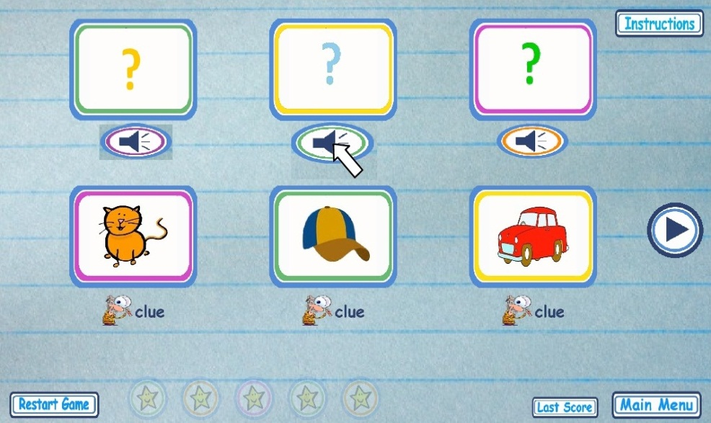

Figure 33 Matching Game Level Three

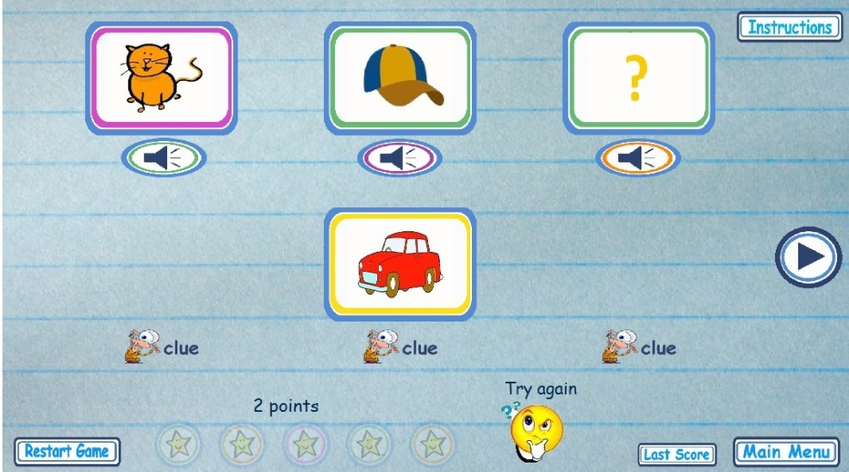

Figure 34 Matching Game Level Three

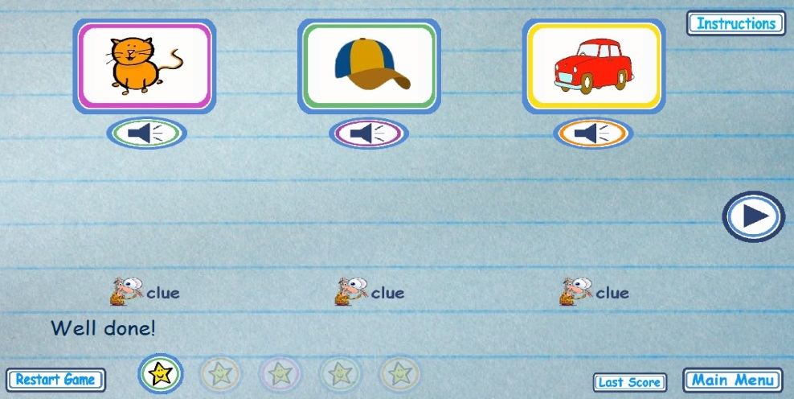

Figure 35 Matching Game Level Three

This level has the following implementation specifics:

* All images (objects, target squares and sound buttons) are added dynamically
* The images are random from a group of images, so the child won’t always have the same images.
* The target images match the 3 random images but are presented in random order. This is to prevent the child solving the game by memory alone.
* The sound buttons are synchronized by code with the random position of the target images.

Example:

1. **for** (**var** Index_objectInSet:uint= 0;Index_objectInSet < 3 ; Index_objectInSet++)
2. {
3. //Definition of Private Variables
4. **var** image = imagesGroup[index_Set][Index_objectInSet];
5. **var** targetImage = targetsGroup[index_Set][Index_objectInSet];
7. // Adding Images, targets - Sets per page ---
8. addChild(imagesGroup[index_Set][Index_objectInSet]);
9. addChild(targetsGroup[index_Set][Index_objectInSet]);
10. //ASSIGNING POSITION TO IMAGES & TARGETS ON STAGE
11. image.x = imagePosition;
12. image.y = 335;
13. imagePosition = image.x + 300;
15. targetImage.x = targetPosition;
16. targetImage.y = 100;
17. targetPosition = targetImage.x + 300;
19. //Adding an Array of Btn_Sounds
20. **var** btnsoundImage=mySoundArray[Index_objectInSet]
21. addChild(mySoundArray[Index_objectInSet])
23. btnsoundImage.x = btnsoundPosition;
24. btnsoundImage.y = 200;
25. btnsoundPosition = btnsoundImage.x + 300;
27. //----SOUND
28. Obtaining the Sound corresponding to each BTNSound -btn sound depends on each target
30. //Assigning each target to a  var
31. **var** Sound1=targetsGroup[index_Set][0]
32. **var** Sound2=targetsGroup[index_Set][1]
33. **var** Sound3=targetsGroup[index_Set][2]
35. //getting the name of the Sound btn corresponding to each target
36. **var** mySoundName1 = "sound" + Sound1.name as String;
37. **var** mySoundName2 ="sound" + Sound2.name as String;
38. **var** mySoundName3 ="sound" + Sound3.name as String;
40. //getting the location of external Sound
41. **var** btnsoundToPlay1="../sound/"+mySoundName1+".mp3" as String
42. **var** btnsoundToPlay2="../sound/"+mySoundName2+".mp3" as String
43. **var** btnsoundToPlay3="../sound/"+mySoundName3+".mp3" as String
44. //loading sounds
45. **var** RequestSoundbtn1:URLRequest = **new** URLRequest(btnsoundToPlay1);
46. **var** RequestSoundbtn2:URLRequest = **new** URLRequest(btnsoundToPlay2);
47. **var** RequestSoundbtn3:URLRequest = **new** URLRequest(btnsoundToPlay3);
48. **var** mybtnSound1:Sound=**new** Sound();
49. **var** mybtnSound2:Sound=**new** Sound();
50. **var** mybtnSound3:Sound=**new** Sound();
52. mybtnSound1.load(RequestSoundbtn1);
53. mybtnSound2.load(RequestSoundbtn2);
54. mybtnSound3.load(RequestSoundbtn3);
56. TheSoundBtn1=mybtnSound1;
57. TheSoundBtn2=mybtnSound2;
58. TheSoundBtn3=mybtnSound3;

## 4.5 Video

The videos are an integral part of this project. They provide extra help for the children to practice the target sounds and words with a visual aid that allows them visualize the articulation of the mentioned words.

### 4.5.1 Research

“When a human being repeats what another person has said, this is speech repetition. Although this may sound insignificant, repetition actually plays a vital role in young children's [language acquisition](http://www.wisegeek.com/what-is-language-acquisition.htm). Vocal imitation arises in [language development](http://www.wisegeek.com/what-is-language-development.htm) before speech comprehension.” [12]

“If your child does have a speech or language delay, his ability to imitate will be an important tool in the therapy process. In fact, if a child does not understand imitation this is one of the first things that a therapist will focus on with your child.” [13]

“Verbal cues teach where you'll need to place your tongue and mouth to make sounds; Visual cues are when you learn by watching someone else talk or by watching yourself in the mirror.” [14]

Speech therapy is vast; treatment varies from person to person. Research showed that one tool used in speech therapy is audio-visual aids. Since imitation is a fundamental part in speech development, visualizing the movement of the mouth gives the child the opportunity to imitate the movement and sound.

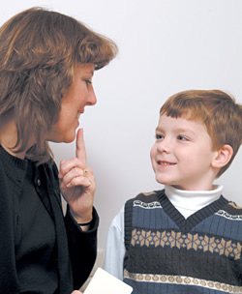

Figure 36. Speech therapy exercise – looking at the speech therapist when producing the sounds.

Examples of videos used in speech exercises:

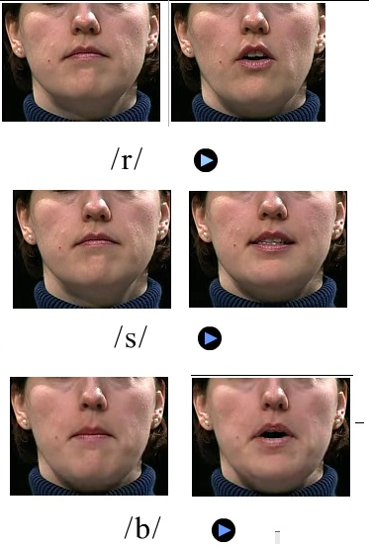

**Figure 37 Example of video: Movement of the mouth and positioning of the lips.**

.

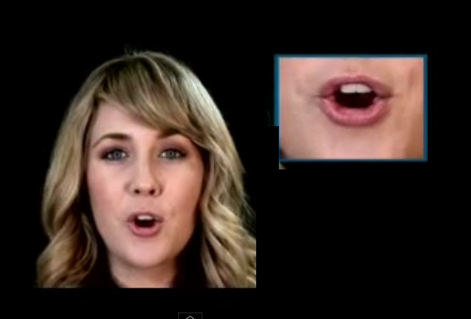

Figure 38 Example of video: Movement of the mouth and positioning of the lips.

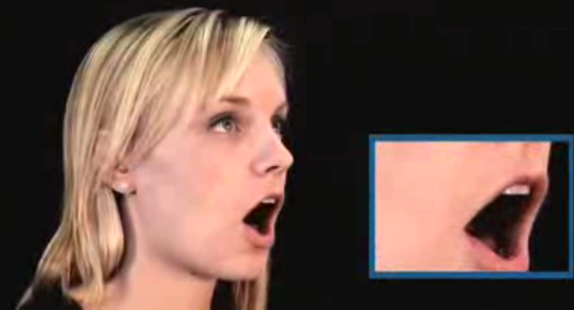

Figure 39 Example of video: Movement of the mouth and positioning of the lips.

### 4.5.2 Filming and Editing Process

Since initially it is intended to promote this website in Ireland, it was decided to have an Irish speaker for the videos. It was extremely useful to have the participation of Siomha Ni Aonghusa.

Siomha followed a script containing all the target sounds and words that were going to be in the videos (see Appendix4).

The filming of the videos took place in DIT Filming Studio.

For the shooting, the following equipment was used:

* 1 Panasonic P2 HD Video Camera
* 1 tripod for the camera
* 1 Radio Mic
* 2 sets of 3 point basic lighting
* 1 microphone AKG 414

The video settings are as follows:

* 960x720 (1.3333)
* 25fps
* 48000Hz -16bit – 4 mono
* Editing Mode was P2 720p

Editing was required for the purposes of this project. All editing was made in Adobe Premier CS5.

The editing settings used in the sequences of this program were:

* Editing Mode: P2 720p, 60 Hz DVCPROHD
* Frame size: 960h 720v (1.3333)
* Frame rate: 23.976fps

The videos in this project, as an audio-visual tool, not only present the sound of the word or target sound but also the movements of the mouth.

It was decided after professional consultation to film only the mouth area instead of the whole face. This prevents the children from being distracted by the features of the face and allows them to concentrate only on the mouth movements.

Examples:

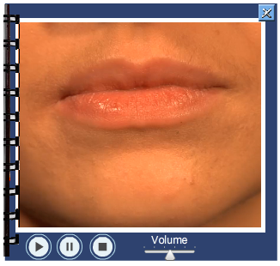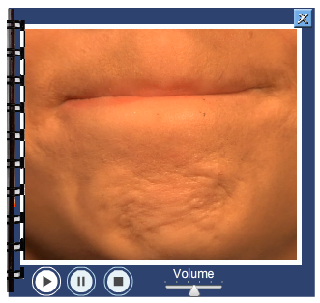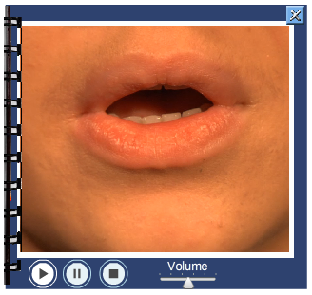

**Figure 40 Example of video: Movement of the mouth or positioning of the lips.**

There are 2 kinds of videos, videos for the target sound and videos for the words. In both types of video, the child is asked to repeat after they hear the word/sound produced.

* The videos for the target sounds (for example: /M/ or /B/) only contain the pronunciation of the target sound. The actor’s mouth only produces the target sound without mentioning any other word so the child does not get distracted.

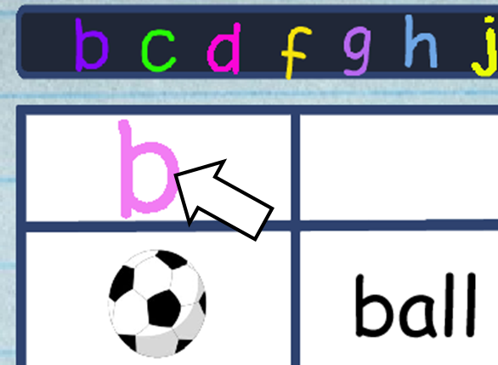 

Figure 41 Example of Target Sound Video

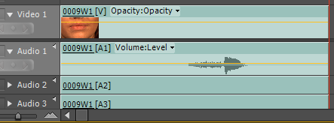

**Figure 42 Example of video editing: Movement of the mouth or positioning of the lips.**

* The videos for the words (e.g. ‘Ball’) contain 4 parts:

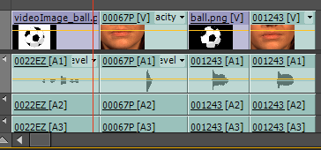

Figure 43 Example of video editing: Movement of the mouth or positioning of the lips.

Part 1 - Instructions: For example “Repeat after me” (Only sound)

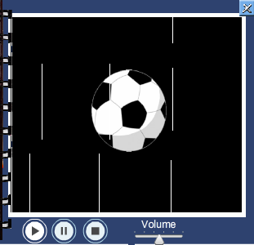

Figure 44 Example of Video of Words- Listen to the instructions

Part 2 – Target Sound: Example /B/

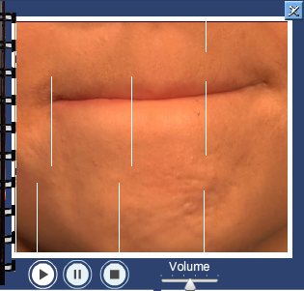

Figure 45 Example of Video of Words- Look and listen to the Target Sound

Part 3 – Word (only sound): For example: “Ball”



Figure 46 Example of Video of Words- Listen to the word

Part 4 – Word – Mouth movement and sound. For example: “Ball”

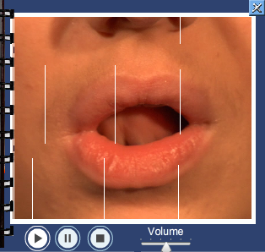

Figure 47 Example of Video of Words- Listen to the word and look the movement of the mouth.

### 4.5.3 Code

The MyVideoWindows.SWF file contains all the code for the videos.

All the videos are MPEG-4 Video for Flash Player (.f4v). These are external files and they are all accessed by code.

Example:

***vidPlayer01B_ball.source = "../videos/word_ball.f4v";***

The video SWF has a frame for each word and sound required. Each frame has FLVplayer on stage where the videos are uploaded.

Depending on the image (event.currentTarget) that the user clicks, the code accesses the video SWF and goes to the corresponding frame

Example:

**currentSWF_B.gotoAndStop(8);**

Since all the video references are contained in one SWF file and this file is external, it can be called by code from any of the other sections in the program like “My sounds words” section or the games sections. This SWF file is loaded first and then depending on what is clicked; it goes to the frame where the corresponding video is.

In the “My sounds words” section, the video is called when clicking the image of the word or the image of the target sound.

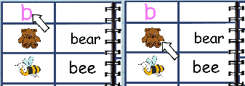

Figure 48 Example of how to get the video in “My Sound Words” pages

The videos are called with the following code:

1. **var** clip_B = **new** Loader();
2. **var** container_B:MovieClip= **new** MovieClip();
3. **var** currentSWF_B:MovieClip= **new** MovieClip();
4. **var** ID_Image_B:MovieClip;
5. clip_B.load(**new** URLRequest("../flash/Prefinal-ClueWindow-01.swf"));
6. pageB.addEventListener(MouseEvent.CLICK,gotoClueWindowB);
7. ball_Image.addEventListener(MouseEvent.CLICK,gotoClueWindowB);
8. bear_Image.addEventListener(MouseEvent.CLICK,gotoClueWindowB);
9. **function** gotoClueWindowB(event:MouseEvent):**void**
10. {   addChild(clip_B);
11. container_B.addChild(clip_B);
12. addChild(container_B);
13. currentSWF_B = MovieClip(clip_B.content);
15. **switch** (event.currentTarget)
16. {  **case** pageB :
17. ID_Image_B = pageB;
18. currentSWF_B.gotoAndStop(1);
19. currentSWF_B.x = 510;
20. currentSWF_B.y = 90;
21. **break**;
22. **case** ball_Image :
23. ID_Image_B = ball_Image;
24. currentSWF_B.gotoAndStop(3);
25. currentSWF_B.x = 510;
26. currentSWF_B.y = 90;
27. **break**;
29. **case** bat_Image :
30. ID_Image_B = bat_Image;
31. currentSWF_B.gotoAndStop(6);
32. currentSWF_B.x = 510;
33. currentSWF_B.y = 90;
34. **break**;
35. }
36. }

In the games, the video is called when clicking the Clue image: Depending on which clue button is clicked; a corresponding video appears.

1. **var** clipL03 = **new** Loader();
2. **var** containerL03:MovieClip= **new** MovieClip();
3. **var** currentSWFL03:MovieClip= **new** MovieClip();
4. **var** ID_ImageL03:MovieClip;
5. clipL03.load(**new** URLRequest("../flash/Prefinal-ClueWindow-01.swf"));
6. **function** gotoClueWindowL03(event:MouseEvent):**void**
7. {
8. addChild(clipL03);
9. containerL03.addChild(clipL03);
10. addChild(containerL03);
11. currentSWFL03 = MovieClip(clipL03.content);
12. **var** videoPositiony=event.currentTarget.y-520;
13. **var** videoPositionx=event.currentTarget.x-210;
14. currentSWFL03.x=videoPositionx;
15. currentSWFL03.y=videoPositiony;
17. **switch** (**true**)
18. {
19. **case** (event.currentTarget.name =="cluecar_mc"):
20. currentSWFL03.gotoAndStop(20);
21. **break**;
22. **case** (event.currentTarget.name =="cluecat_mc") :
23. currentSWFL03.gotoAndStop(24);
24. **break**;
25. **case** (event.currentTarget.name =="cluecap_mc"):
26. currentSWFL03.gotoAndStop(26);
27. **break**;
28. **case** (event.currentTarget.name =="cluesea_mc"):
29. currentSWFL03.gotoAndStop(40);
30. **break**;
31. }
32. }

## 4.6 Audio

In this project, sound repetition is crucial. The “My Sound Words” section includes the correct sound pattern when playing the videos, not only the correct pronunciation of the word but, most importantly, the pronunciation of the target sound.

The voice in the program is provided by Siomha, it was important for the purpose of the project to have an Irish voice since the primary target audience is Irish children.

In the games, hearing the word is a fundamental element. The children have to listen to the words in order to be able to answer correctly.

However, the audio was not only used in the games and vocabulary regarding oral production but it was also use to complement the visual reinforcement and the instructions.

### 4.6.1 Research

The list of target sounds (/B/, /P/, /M/,/D/, /T/,/L/, /N/,/F/, /V/,/S/, /Z/,/SH/, /J/,/CH/, /R/,/W/, /Y/,/K/, /C/,/G/, /H/) was provided by Speech Pathologist Barbara Hallahan.

The words were written by the author and revised by the project’s specialist consultant, B. Hallahan.

### 4.6.2 Process

In order to be prepared for the filming, Siomha studied a video, filmed in a digital camera for the project purposes. In this video Barbara Hallahan shows the correct pronunciation of the target sounds.

The audio was edited from the film sequences.

The editing settings used in the sequences of this program were:

* Editing Mode: P2 720p, 60 Hz DVCPROHD
* Frame size: 960h 720v (1.3333)
* Frame rate: 23.976fps

Audio editing was made in Adobe Premier CS5.

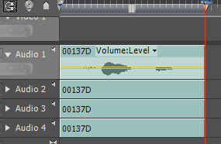

Figure 49 Example of Audio editing.

### 4.6.3 Code

All the audio files are MP3. The MP3 files to do with the words are external files and called by code. The ones regarding the reinforcements and instructions were all imported and are used as internal files.

* 1. External Audio Files: The audio regarding the words for the children to practice and to learn the target sounds can be found in the game section.

During the game, the children are required to press the sound button in order to listen to the word.



Figure 50 Example of the sound button in the game section

1. //----SOUND -Obtaining the Sound corresponding to each BTNSound -btn sound depends on each target
2. //Assigning each target to a  var
3. **var** Sound1=targetsGroup[index_Set][0]
4. **var** Sound2=targetsGroup[index_Set][1]
5. **var** Sound3=targetsGroup[index_Set][2]
6. //getting the name of the SoundBtn corresponding to each target
7. **var** mySoundName1 = "sound" + Sound1.name as String;
8. **var** mySoundName2 ="sound" + Sound2.name as String;
9. **var** mySoundName3 ="sound" + Sound3.name as String;
11. //getting the location of external Sound
12. **var** btnsoundToPlay1="../sound/"+mySoundName1+".mp3" as String;
13. **var** btnsoundToPlay2="../sound/"+mySoundName2+".mp3" as String
14. **var** btnsoundToPlay3="../sound/"+mySoundName3+".mp3" as String;
15. //loading sounds
16. **var** RequestSoundbtn1:URLRequest=**new** URLRequest(btnsoundToPlay
17. **var** RequestSoundbtn2:URLRequest=**new** URLRequest(btnsoundToPlay2)
18. **var** RequestSoundbtn3:URLRequest=**new** URLRequest(btnsoundToPlay3)
20. **var** mybtnSound1:Sound=**new** Sound();
21. **var** mybtnSound2:Sound=**new** Sound();
22. **var** mybtnSound3:Sound=**new** Sound();
24. mybtnSound1.load(RequestSoundbtn1);
25. mybtnSound2.load(RequestSoundbtn2);
26. mybtnSound3.load(RequestSoundbtn3);
28. TheSoundBtn1=mybtnSound1;
29. TheSoundBtn2=mybtnSound2;
30. TheSoundBtn3=mybtnSound3;
31. //--end--Obtaining the Sound
32. // --- 1.-  Btn_Sounds -------
33. BtnSound_1.addEventListener(MouseEvent.CLICK, giveamySound1);
34. **function** giveamySound1(e:MouseEvent):**void**
35. {   TheSoundBtn1.play();   }
36. BtnSound_2.addEventListener(MouseEvent.CLICK, giveamySound2)
37. **function** giveamySound2(e:MouseEvent):**void**
38. {      TheSoundBtn2.play(); }
40. BtnSound_3.addEventListener(MouseEvent.CLICK, giveamySound3);
41. **function** giveamySound3(e:MouseEvent):**void**
42. {
43. TheSoundBtn3.play();
44. }
45. // ---END 1.-  Btn_Sounds -------
    1. Internal Audio Files:

The instructions are available at all times for the user. These can be accessed by clicking the ‘Instructions’ Button



These instructions are presented in 2 different ways:

* When the children click the Instructions Button at the beginning of each game level or ‘My Sound Words’ section, it not only allows them to listen to the instructions but also plays a visual demo of what the user should do.

1. //INSTRUCTIONS - VOICE & Demo
2. instructionsLevel01.visible=**true**;
3. **var level01_Sound:Sound = new instructionsLevelsB ;**
5. instructionsLevel01.addEventListener(MouseEvent.CLICK, instructions_L01);
6. **function** instructions_L01(e:MouseEvent):**void**
7. {
8. **level01_Sound.play();**
9. playBtn01_L01.visible=**true**;
10. instructionsLevel01.visible=**false**;
11. demoMc01_Image.visible=**true**;
12. demoMc02_Image.visible=**true**;
13. demoMc03_Image.visible=**true**;
14. demoMc01_Target.visible=**true**;
15. demoMc01_SoundBtn.visible=**true**;
16. demoMc01_arrowMouse.visible=**true**;
17. play();
19. }

* There is an instructions button that activates the audio for the instructions that can be found in all the dictionary pages and all games pages.

Code for the ‘My Sound Words’ (dictionary) section:

1. **var DInstructions_B:Sound = new Instr_Dictionary01;**
2. instructionBtn02_B.addEventListener(MouseEvent.CLICK , instructionsB);
3. **function** instructionsB(evt:MouseEvent):**void**
4. {
5. **DInstructions_B.play();**
6. }

Code for the Matching Game:

1. **var level01_Sound:Sound = new instructionsLevelsB ;**
2. instructions2Level01.addEventListener(MouseEvent.CLICK, instructionsDuringGame);
3. **function** instructionsDuringGame(event:MouseEvent):**void**
4. {
5. **level01_Sound.play();**
6. }

The sounds that complement the visual reinforcement are called by the following code:

1. // --- 2.-  FeedBack Sounds -------
2. **var positiveL03:Sound = new veryGood;**
3. **var negativeL03:Sound = new tryAgain;**
4. //--------------------------------------
5. {   //IF - object on correct target
6. event.target.removeEventListener(MouseEvent.MOUSE_DOWN, pickupObject);
7. event.target.removeEventListener(MouseEvent.MOUSE_UP, dropObject);
8. event.target.buttonMode = **false**;
9. event.target.x = matchingTarget.x;
10. event.target.y = matchingTarget.y;
12. points++;
13. pointsField.text = String(points) + " points";
14. response_txt.text = "Correct!";
15. response_mc.gotoAndStop(2);
16. **positiveL03.play();**
17. }
18. **else**
19. {
20. //ELSE - object on incorrect target
21. event.target.x = objectoriginalX;
22. event.target.y = objectoriginalY;
23. response_txt.text = "Try again";
24. response_mc.gotoAndStop(3);
25. **negativeL03.play();**
26. }

# Website

The website is called **Speaking is Fun** and is publicly available at [www.speakingisfun.com](http://www.speakingisfun.com). The website uses HTML5, CSS and JavaScript.

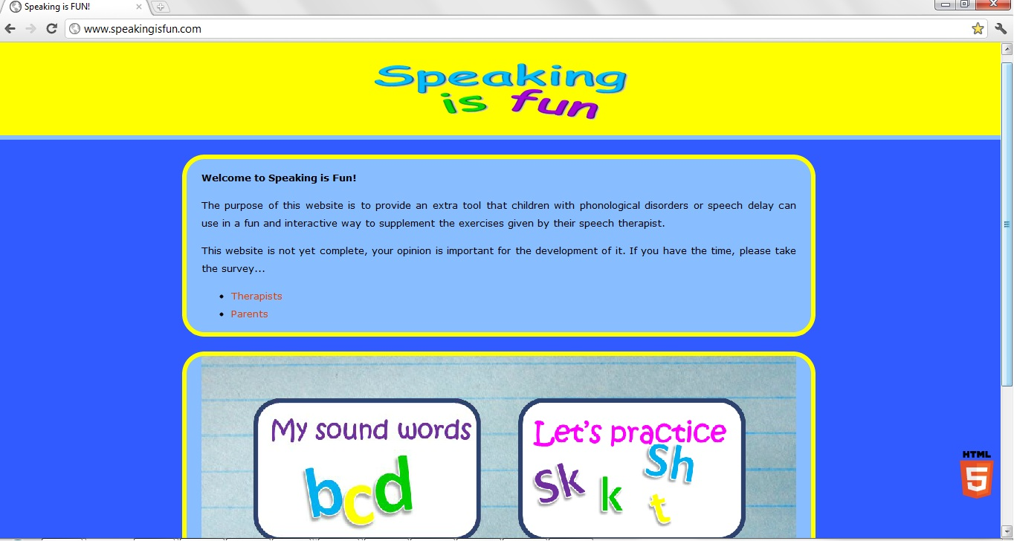

Figure 51: The publicly available site.

* HTML5

Standards compliant HTML5 was used to create the site. This means that the site should render correctly on all modern browsers. Furthermore, it allowed for far cleaner mark-up code than HTML4.

The website was validated as HTML5 standards compliant by the World Wide Web Consortium (W3C), the organisation responsible for the HTML5 specification. A link to the W3C HTML5 validator is provided on the site.

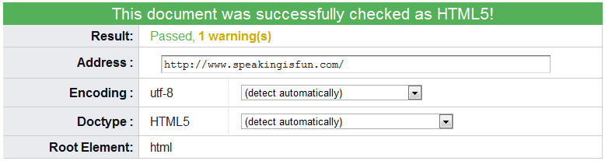

Figure 52: Results from the World Wide Web Consortium HTML5 validator.

* CSS

CSS 2.1 was used for the presentation (e.g. layout and colours) of the site.

Since the target audience for the site is young children, bright friendly colours were deliberately used. The design is minimalist so as not to distract from the Flash application.

* JavaScript

An open-source JavaScript library called SWFObject was used to embed the Flash application on the site. This provided a reliable method of embedding the Flash content across all browsers and, consequently, reduced the likelihood of issues.

* Search Engine Optimisation (SEO)

To increase the likelihood of users finding the site via a web search, some basic SEO was performed. HTML ‘keywords’ and ‘description’ META tags were added to provide a guide to the search engines as to the content of the site.

* Browser Testing

The site was tested on the latest versions of Internet Explorer, FireFox and Chrome. Due to the use of standards compliant HTML5, CSS and the SWFObject JavaScript library, no issues were encountered.

# User Test and Evaluation

## 6.1 User Testing by Specialists.

Since the beginning of the application development, it has been monitored and tested by Speech Pathologist Barbara Hallahan. This was crucial since it ensured that application development proceeded in the right direction regarding speech therapy specifics. Barbara was also on-hand to review the application from a specialist point of view; a specialist that has first-hand experience with children with speech disorders and has in-depth knowledge of what they might find easy or difficult.

### 6.1.1 User Test and Suggestions

* 1. Throughout the different stages of development, there were a number of specialists that regularly tested the application providing not only their expertise in speech therapy but also testing and highlighting any issues with the application. These specialists also assisted in answering surveys during the background research.
  2. There was a survey posted to the Facebook page of various Speech Therapist associations. The survey was also given to a number of Speech Pathologists by Barbara Hallahan at the ASHA Conference USA 2011. In this Survey, answered in different stages of the development, the specialists gave their opinions and suggestions about the application:

Examples:

* “My Suggestions: It would be great if the voice used was the voice of an Irish speaker so that the picture sounds could be discriminated easier by Irish children who would be more familiar with the accent of an Irish speaker. I understand that the website is currently under development but I believe it could be very useful to Speech and Language Therapists when it is up and running properly.” *Carmel McCarthy Speech & Language Therapist, The Speech Centre.*

**Status**: This was solved by bringing an Irish Speaker to collaborate in the project and provide her voice for the sounds and videos.

* “I managed to get into the sounds and pictures (I hadn't realised I was meant to double-click on the picture, there was no instruction to do so). The only one I could see was the /b/ one - this is a very visual sound to produce (i.e. clear to see the lip closure) so I thought the video was good with it.” *Pamela Raftery, Speech Therapists, Private Practice.*

**Status:** Because of this comment and some other specialist suggestions, the Demo with instructions was added.

* Hard to remember the oral instructions for the tasks - it would help if they were available as an optional button for further information, as in my experience, people go straight to play without listening.

**Status**: This was solved by adding an instructions button that the user can always access.

## 6.2 User testing by Parents of children with Phonological disorders / delay speech.

It was always intended to have input from parents with children with phonological disorders / speech delay. It was not possible to do it face-to-face so a link to the website and a survey was posted on the various Facebook pages of a number of parent associations for children with speech disorders. Some of the responses are below:

* Association: [Children with Speech Delay](https://www.facebook.com/groups/84861567584/) - [Open Group](https://www.facebook.com/groups/84861567584/)

[K.C](http://www.facebook.com/n/?karson12&mid=55d9390G2952f0cfG7860f75G96&bcode=IH1FtBYC&n_m=whitecita%40yahoo.com): “it’s good keep going”

[S.M.S](http://www.facebook.com/n/?profile.php&id=695342641&mid=55d9390G2952f0cfG7860f75G96&bcode=IH1FtBYC&n_m=whitecita%40yahoo.com).: “Looks good keep going. If I could make a suggestion maybe a game with colours, shapes and animals”

* Association: [CHERAB Foundation for apraxia, autism, speech disorders, late talkers](https://www.facebook.com/groups/cherab/)

L.G: “I started to look at this and wanted to have more time to add more input -but just quick wanted to say it's quite amazing the way you show the mouth movements up close. I know Tanner always used to watch the way people's mouths moved when they spoke. I just wanted to make sure you know that I believe it's incredible what you are doing!!!”

## 6.3 User testing by children

The application was tested at the Newtownmountkennedy Community Playgroup. At all times it was supervised by project consultant, specialist Barbara Hallahan.

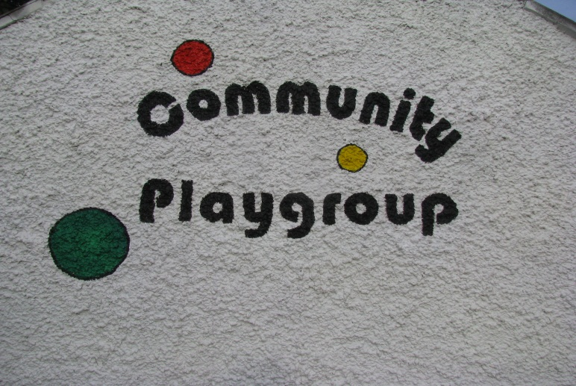

Figure 53 - Newtownmountkennedy Community Playgroup

The user test group was composed of 8 children in preschool; ages varied from 3 to 5 years old.

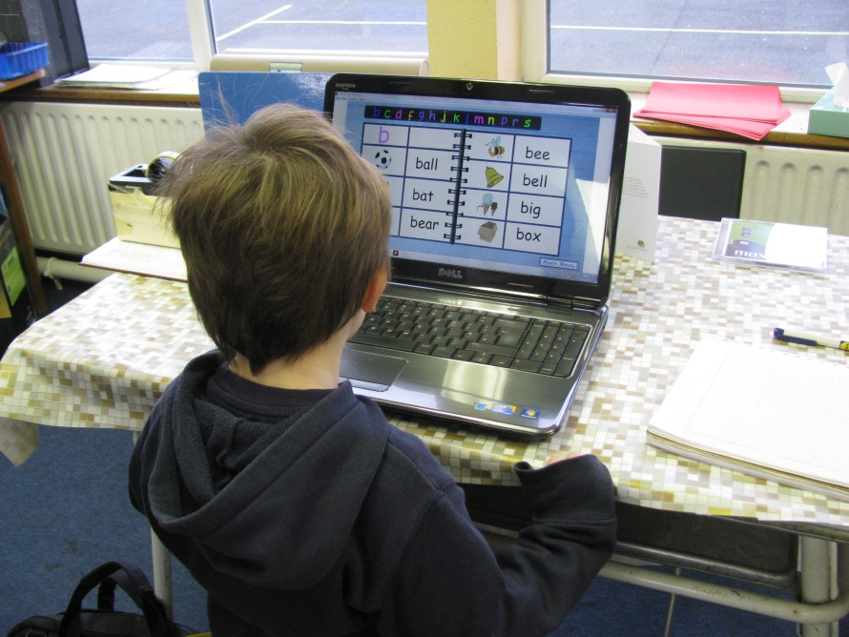

Figure 54 Aaron in “My Sound Words” section.

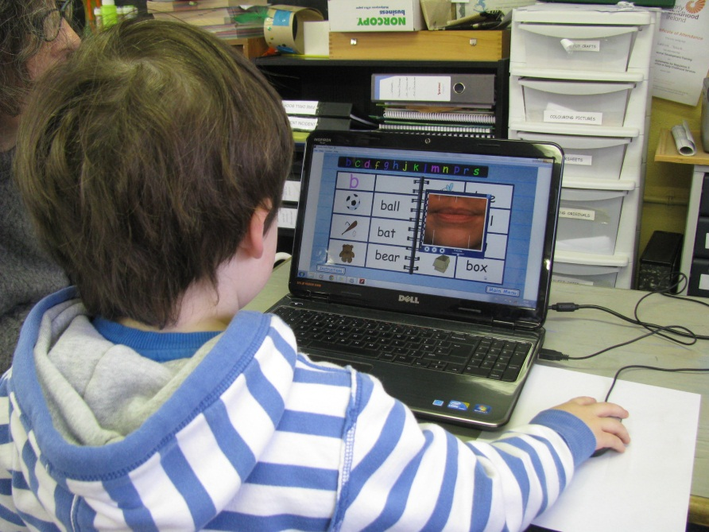

Figure 55 Luca (Age: 3 y.o.), playing the videos in the “My Sound Words” section.

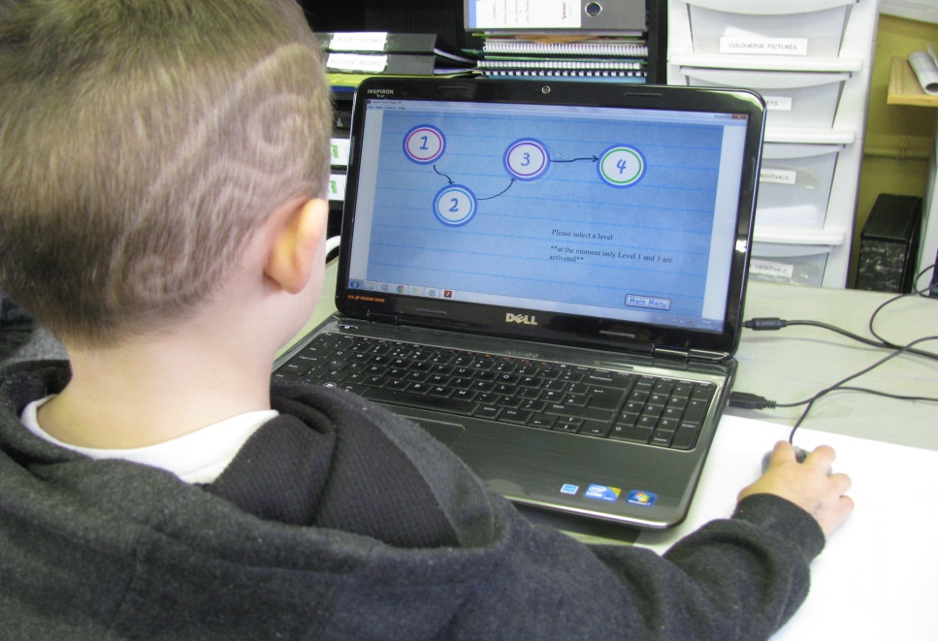

Figure 56 Matthew (Age: 4 y.o.), starting the matching game in the level selection part.

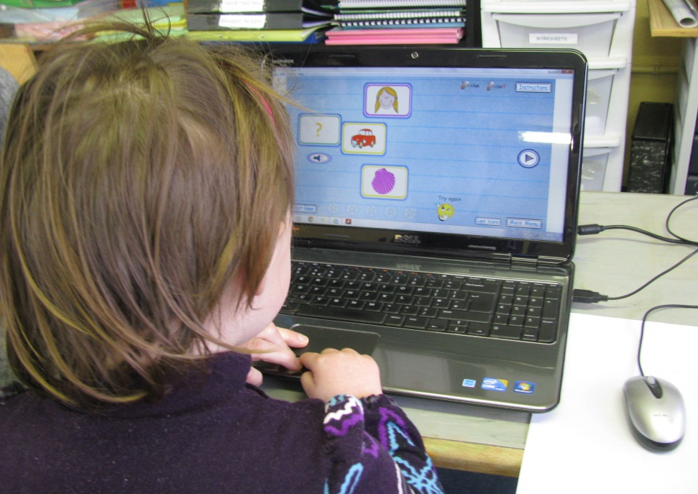

Figure 57 Ava (Age: 3 y.o.), playing on level 1 of the Matching Game

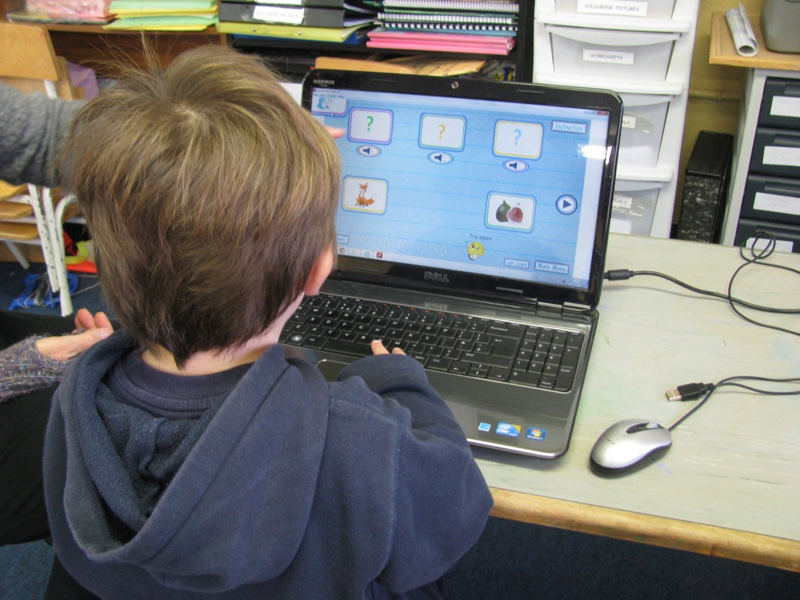

Figure 58 Josh (Age: 3 y.o.), playing on level 3 of the Matching Game

The user testing with children was very successful and was liked by the children. In particular, they liked the voices and would repeat the words in the videos.

Here are some details that came to light when the kids were using the application:

* Due to their age, some of the children couldn’t read yet. So when they were navigating, some buttons were difficult for them to understand like ‘Restart the game’ or the instructions button.

**Status:** This will be fixed in the future by using easily recognisable images for the links.

* When the video started, the children were confused when they clicked the image and nothing happened. Then they were told that they have to click play to run it.

**Status:** This problem was solved by making the video play automatically.

Overall the speech pathologist that guided the children when testing the application was very satisfied with the results and the children’s attitude towards the application.

## 6.4. Bug Report

* In level 1, the images, from a group of 5 objects, are randomized and then just 3 images are shown. The group of target images was passed through the random function as well and just one image was shown.

**Problem**: Sometimes the target image was not a match for any of the 3 images shown.

**Solution:** Instead of having a group of target images being randomized separately without any connection to the group of object images, the program first determines the 3 object images that are going to be shown. It then searches for their matching target images and creates a group of target images that is randomize. Once this happens, one target image is selected and displayed on screen.

1. //Getting the names of the 3 Images and getting their Target name
2. **var** image1=imagesGroup_L01[index_SetL01] [0]
3. **var** image2=imagesGroup_L01[index_SetL01] [1]
4. **var** image3=imagesGroup_L01[index_SetL01] [2]
6. **var** myTargetName1 = "target" + image1.name as String;
7. **var** myTargetName2 = "target" + image2.name as String;
8. **var** myTargetName3 = "target" + image3.name as String;
10. //Assigning the Class name to the targets
11. **var** myTarget1=getDefinitionByName(myTargetName1) as Class;
12. **var** myTarget2=getDefinitionByName(myTargetName2) as Class;
13. **var** myTarget3=getDefinitionByName(myTargetName3) as Class
15. //Definition of the targets
16. **var** Thetarget1:MovieClip = **new** myTarget1;
17. Thetarget1.name = myTargetName1;
18. **var** Thetarget2:MovieClip = **new** myTarget2;
19. Thetarget2.name = myTargetName2;
20. **var** Thetarget3:MovieClip = **new** myTarget3;
21. Thetarget3.name = myTargetName3;
22. trace("Thetarget3: " +Thetarget3)
24. //Creating an Array of Targets
25. **var** myTargetArray:Array = [Thetarget1,Thetarget2,Thetarget3]
26. }
27. // Randomizing the TargetArray
28. myTargetArray.sort
29. (**function** ()
30. {
31. **return** Math.round(Math.random());
32. });
33. //Selecting only ONE target from the Array
34. **var** myTarget=myTargetArray [1];
35. addChild(myTarget)
36. myTarget.x = 160;
37. myTarget.y = 200

**Status**: Working well.

* **Problem:** In level 3, the order of presentation or location of the correct answers (target image) is always the same. It should shift as otherwise children will quickly learn by location rather than by auditory input (reported by a therapist).

**Solution**: This was solved by creating a function than randomized the object images as well as the target images.

1. //RANDOM FUNCTION -------
2. **function** randomizeArray(array:Array):Array
3. {
4. **var** array_copy:Array = array.concat();
5. **var** newArray:Array = **new** Array();
6. **while**(array_copy.length > 0)
7. {
8. newArray.push(array_copy.splice(Math.floor(Math.random() *array_copy.length), 1)[0]);
9. }
10. **return** newArray;
11. }
12. //----------END------ RANDOM FUNCTION---------
14. //Adds the arrays of dragable images, targets to another array.
15. imagesGroup.push(randomizeArray(set1),randomizeArray(set2),randomizeArray(set3),randomizeArray(set4), randomizeArray(set5));
16. targetsGroup.push(randomizeArray(targetset1),randomizeArray(targetset2), randomizeArray(targetset3),randomizeArray(targetset4), randomizeArray(targetset5));

**Status**: Solved. Working well.

* **Problem**: Although most of the kids were able to use the mouse or touchpad, there were 1 or 2 that had a bit of difficulty. This could be a problem if the child also has any motor skills disorder or problems handling a mouse.

**Solution**: This can be solved by making the application accessible by keyboard. In particular, by allowing the user to drag and drop (or some other method of selection) by using the arrow keys.

**Status**: In progress.

* **Problem**: In level 3, the final score is shown before the child moves the correct image to its place. The score is shown as soon as the user makes any dragging even if it is incorrect.

**Solution**: This requires a change to the game code; adjusting the condition that displays the final score of the level.

**Status:** In progress.

## 6.5. Heuristic Evaluation

The user test was able to show some heuristic characteristics that have been covered in this application.

**User control and freedom:**

If the user selects a section and decides to go back to where they were before, the application supports this by providing links to go to the main menu of the application or go back to the section menu.

**Consistency and standards:**

Throughout the application, all the sections use very similar presentation. They are consistent with each other.

**Recognition rather than recall**:

This can be applied to the use of the instruction buttons. At the beginning of the games or the vocabulary section, the user has the opportunity to see a demo explaining what he/she needs to do in that specific section. The demo is only available at the beginning of each section; however the user can access the audio instructions, as many times as wanted, using the instruction button.

Instead of just listening and looking at the demo one time, the user has the opportunity to listen to the instructions as many times as they want.

**Help users recognize, diagnose, and recover from errors**:

During the game, if the child makes a mistake, there is a voice and an image that tells him to try again, meaning that his answer is not correct. There is also a positive reinforcement voice and image if he answers correctly.

One therapist had this to say:

“I found it fairly easy to navigate, which leads me to think the average parent would find it slightly easy-moderately user friendly.”

# Future development

This website and its phonetics application have enormous potential to grow. There are so many things that can be improved.

On-going work, according to the original plan, will include:

* Game Level Two:

This level presents 3 words but 1 or 2 with the target sound and one word that is completely different. Example: **/B/** - **B**at – **B**ear – **H**ouse.

* Game Level Four:

This level will use the **Minimal Pairs** technique. This means having 2 words, one with the target sound and the other with the expected error. Example: Bear/Pear, Pan/Man.

* Activate all Target Sound pages in the section “My Sound Words”. At the moment, for project prototype purposes the pages from B to L contain images and only pages B and C include videos.
* Second Game as originally planned. This game will introduce the child to sentences.
* 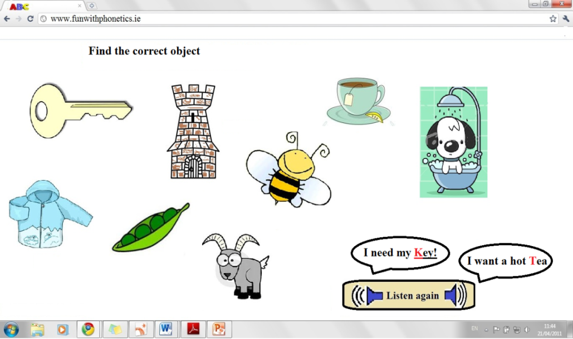

Figure 59 Idea for a second game.

In addition, based on suggestions from speech specialists and parents with children speech disorders, there are a number of additional ideas for possible future work:

* Possibility to add another level to the matching game using **Multiple Pair** Exercises. This means 3 or more words that sound similar but have different target sound. Example: **T**en / **H**en / **P**en or **K**ey/**B**ee/**T**ea.
* A game for each individual Target Sound could be developed.

# Conclusion

To conclude, after extensive research and consultation with parents and therapists, it is clear that there is a definite need for interactive web tools for children with phonological disorders.

Parents mentioning that “more needs to be done to support children with speech disorders”, “young kids need it to be fun and designed as a game” and therapists commenting that “web-based practice would be a great supplementary tool” confirm that there is a big opportunity for this application.

Furthermore, the vast field of Speech Therapy allows this application to be able to expand and cover different techniques, allowing children to have a more thorough practice of their speech therapy exercises at home.

# Appendix List

## Appendix 1 - Paper based exercises

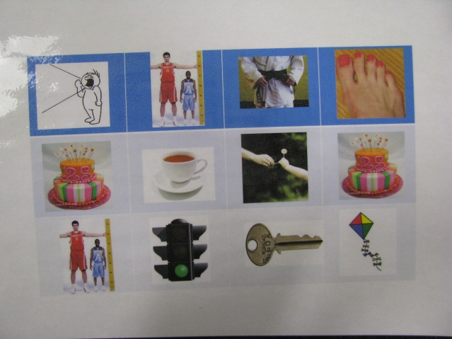 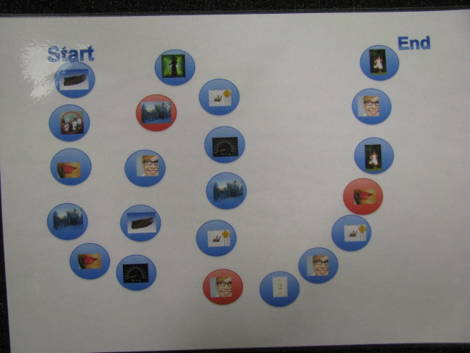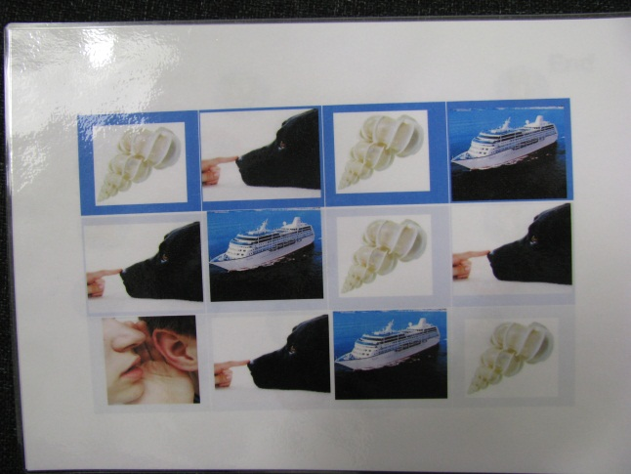

## Appendix 2

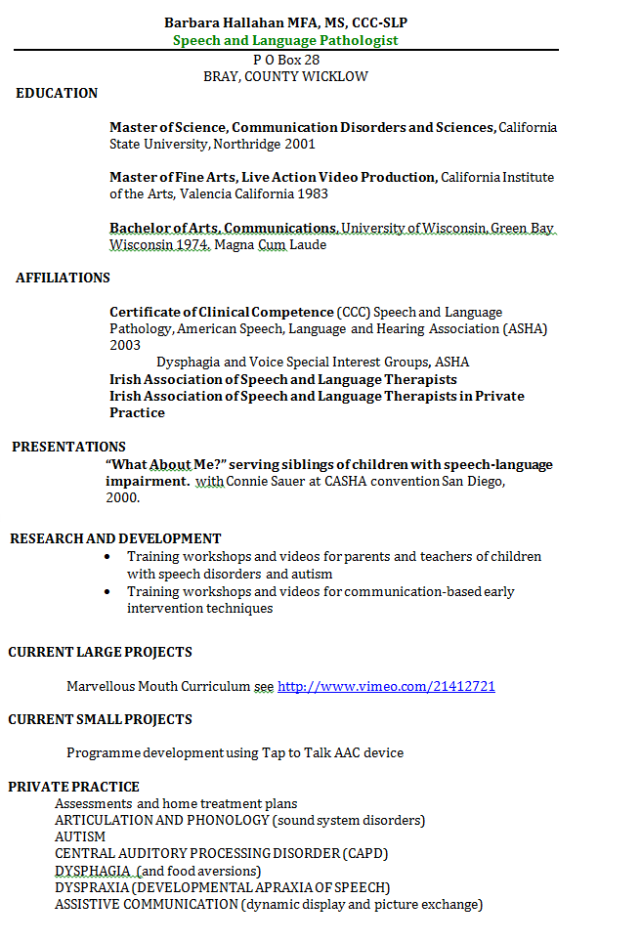

## Appendix 3 – Competitive analysis – websites.

### Appendix 3.1

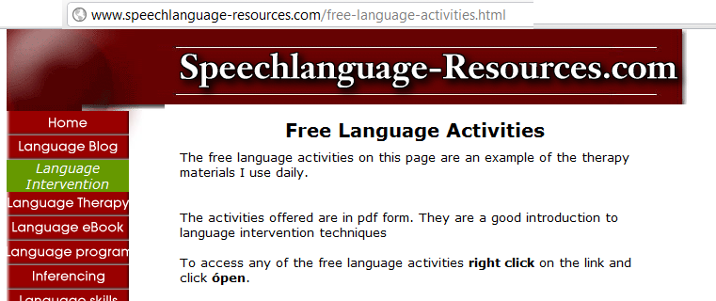

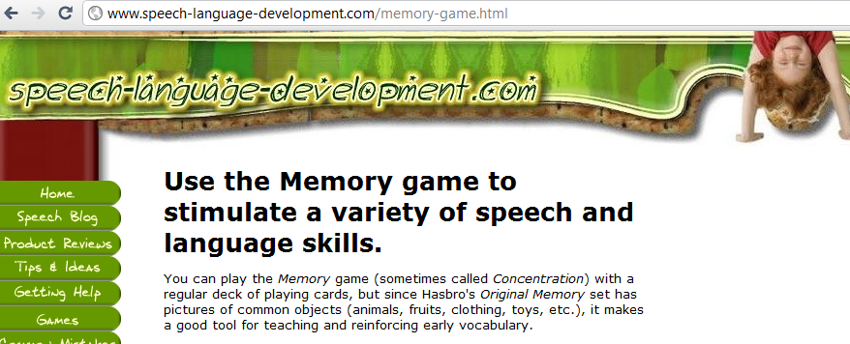

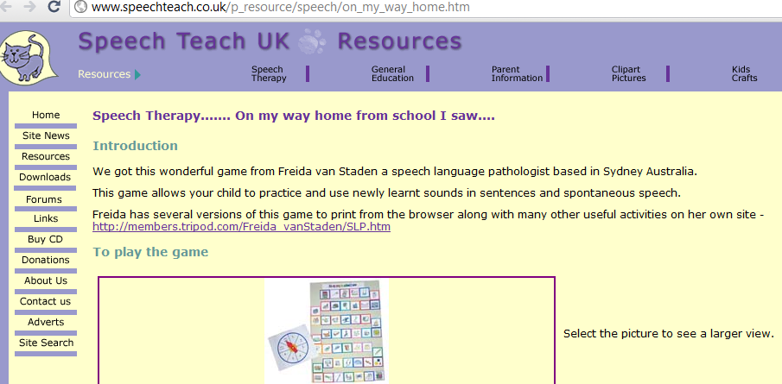

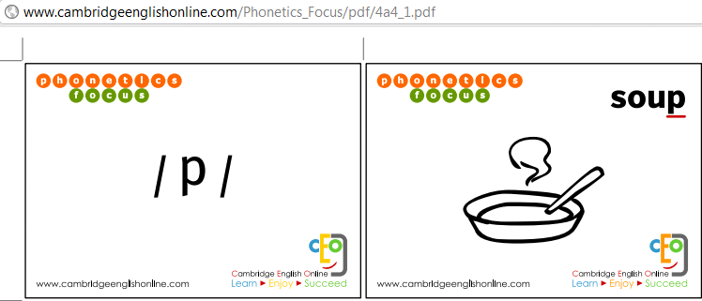

### Appendix 3.2

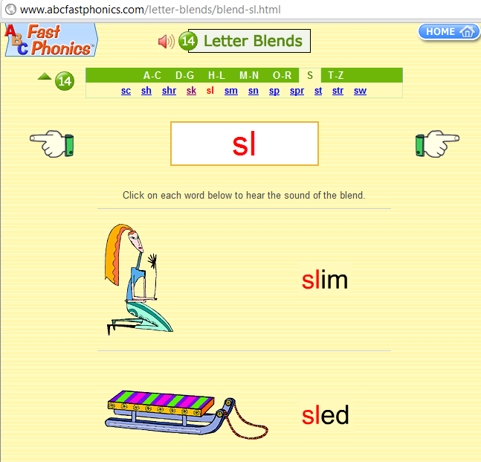

### Appendix 3.3

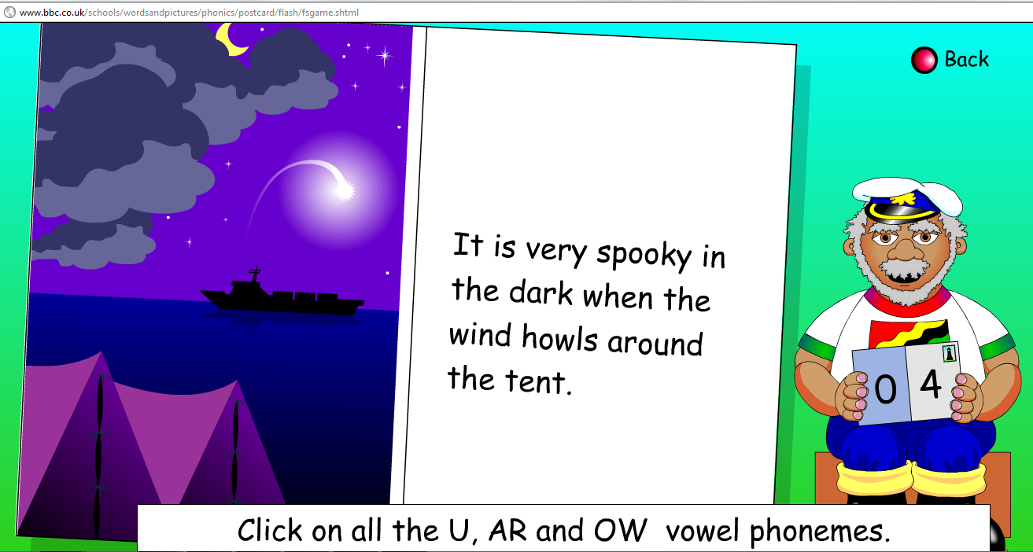

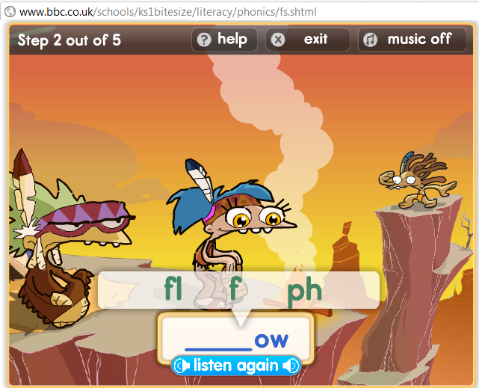

## Appendix 4 – Video and Sound Script

### Appendix 4.1 Target Sounds

|  |  |  |  |
| --- | --- | --- | --- |
| B | /bah/ | *1.2.3.4.5* | /bah/ |
|  |  |  |  |
| P | /pa/ | *1.2.3.4.5* | /pa/ |
|  |  |  |  |
| M | /mah/ | *1.2.3.4.5* | /mah/ |
|  |  |  |  |
| D | /**D**ah/ | *1.2.3.4.5* | /**D**ah/ |
|  |  |  |  |
| T | /**T**ah/ | *1.2.3.4.5* | /**T**ah/ |
|  |  |  |  |
| L | /lah/ | *1.2.3.4.5* | /lah/ |
|  |  |  |  |
| N | /nah/ | *1.2.3.4.5* | /nah/ |
|  |  |  |  |
| F | /fa/ | *1.2.3.4.5* | /fa/ |
|  |  |  |  |
| V | /vah/ | *1.2.3.4.5* | /vah/ |
|  |  |  |  |
| S | /sah/ | *1.2.3.4.5* | /sah/ |
|  |  |  |  |
| Z | /zzah | *1.2.3.4.5* | /zzah |

|  |  |  |  |
| --- | --- | --- | --- |
| SH | /sha/ | *1.2.3.4.5* | /sha/ |
|  |  |  |  |
| J | /ja/ | *1.2.3.4.5* | /ja/ |
|  |  |  |  |
| CH | /cha/ | *1.2.3.4.5* | /cha/ |
|  |  |  |  |
| R | /**R**ah/ | *1.2.3.4.5* | /**R**ah/ |
|  |  |  |  |
| W | /**wah/** | *1.2.3.4.5* | /**wah/** |
|  |  |  |  |
| Y | /ja/ | *1.2.3.4.5* | /ja/ |
|  |  |  |  |
| K | /k/ | *1.2.3.4.5* | /k/ |
|  |  |  |  |
| C | /k/ | *1.2.3.4.5* | /k/ |
|  |  |  |  |
| G | /**G**a/ | *1.2.3.4.5* | /**G**a/ |
|  |  |  |  |
| H | /ha/ | *1.2.3.4.5* | /ha/ |

### Appendix 4.1 Words

|  |  |  |
| --- | --- | --- |
|  | WORDS |  |
|  |  |  |
| B |  |  |
| **ball** | *1.2.3.4.5* | **ball** |
| **bat** | *1.2.3.4.5* | **bat** |
| **bear** | *1.2.3.4.5* | **bear** |
| **bee** | *1.2.3.4.5* | **bee** |
| **bell** | *1.2.3.4.5* | **bell** |
| **big** | *1.2.3.4.5* | **big** |
| **box** | *1.2.3.4.5* | **box** |
|  |  |  |
|  |  |  |
| C |  |  |
| **car** | *1.2.3.4.5* | **car** |
| **coat** | *1.2.3.4.5* | **coat** |
| **cat** | *1.2.3.4.5* | **cat** |
| **cap** | *1.2.3.4.5* | **cap** |
|  |  |  |
| CH |  |  |
| **cheese** | *1.2.3.4.5* | **cheese** |
| **chair** | *1.2.3.4.5* | **chair** |
| **cherry** | *1.2.3.4.5* | **cherry** |
| **chicken** | *1.2.3.4.5* | **chicken** |
|  |  |  |
| D |  |  |
| **doll** | *1.2.3.4.5* | **doll** |
| **dog** | *1.2.3.4.5* | **dog** |
|  |  |  |
| F |  |  |
| **fox** | *1.2.3.4.5* | **fox** |
| **fan** | *1.2.3.4.5* | **fan** |
| **fig** | *1.2.3.4.5* | **fig** |
| **fox** | *1.2.3.4.5* | **fox** |
| **fan** | *1.2.3.4.5* | **fan** |
| **fig** | *1.2.3.4.5* | **fig** |
|  |  |  |
| G |  |  |
| **goat** | *1.2.3.4.5* | **goat** |
| **girl** | *1.2.3.4.5* | **girl** |
| **gate** | *1.2.3.4.5* | **gate** |
|  |  |  |
| H |  |  |
| **hen** | *1.2.3.4.5* | **hen** |
| **house** | *1.2.3.4.5* | **house** |
| **hug** | *1.2.3.4.5* | **hug** |
| **hat** | *1.2.3.4.5* | **hat** |
|  |  |  |
| J |  |  |
| **juice** | *1.2.3.4.5* | **juice** |
| **jam** | *1.2.3.4.5* | **jam** |
| K |  |  |
| **kite** | *1.2.3.4.5* | **kite** |
| **key** | *1.2.3.4.5* | **key** |
|  |  |  |
| L |  |  |
| **light** | *1.2.3.4.5* | **light** |
| **lion** | *1.2.3.4.5* | **lion** |
| **lemon** | *1.2.3.4.5* | **lemon** |
| **lamp** | *1.2.3.4.5* | **lamp** |

|  |  |  |
| --- | --- | --- |
| M |  |  |
| **man** | *1.2.3.4.5* | **man** |
| **mug** | *1.2.3.4.5* | **mug** |
| **mop** | *1.2.3.4.5* | **mop** |
| **mouse** | *1.2.3.4.5* | **mouse** |
|  |  |  |
| N |  |  |
| **night** | *1.2.3.4.5* | **night** |
| **nine** | *1.2.3.4.5* | **nine** |
| **net** | *1.2.3.4.5* | **net** |
|  |  |  |
| P |  |  |
| **pan** | *1.2.3.4.5* | **pan** |
| **pea** | *1.2.3.4.5* | **pea** |
| **pig** | *1.2.3.4.5* | **pig** |
| **pie** | *1.2.3.4.5* | **pie** |
| **pear** | *1.2.3.4.5* | **pear** |
| **pen** | *1.2.3.4.5* | **pen** |
|  |  |  |
| R |  |  |
| **rope** | *1.2.3.4.5* | **rope** |
| **rain** | *1.2.3.4.5* | **rain** |
| **right** | *1.2.3.4.5* | **right** |
| **red** | *1.2.3.4.5* | **red** |
|  |  |  |
| S |  |  |
| **sock** | *1.2.3.4.5* | **sock** |
| **sea** | *1.2.3.4.5* | **sea** |
| **seat** | *1.2.3.4.5* | **seat** |
| **seal** | *1.2.3.4.5* | **seal** |

|  |  |  |
| --- | --- | --- |
| **Sh** |  |  |
| **shell** | *1.2.3.4.5* | **shell** |
| **shower** | *1.2.3.4.5* | **shower** |
| **shoe** | *1.2.3.4.5* | **shoe** |
|  |  |  |
| **T** |  |  |
| **tea** | *1.2.3.4.5* | **tea** |
| **tie** | *1.2.3.4.5* | **tie** |
| **tall** | *1.2.3.4.5* | **tall** |
| **ten** | *1.2.3.4.5* | **ten** |
| **tights** | *1.2.3.4.5* | **tights** |
| **tower** | *1.2.3.4.5* | **tower** |
|  |  |  |
|  |  |  |
| **V** |  |  |
| **vest** | *1.2.3.4.5* | **vest** |
| **violin** | *1.2.3.4.5* | **violin** |
| **vase** | *1.2.3.4.5* | **vase** |
|  |  |  |
| **W** |  |  |
| **wing** | *1.2.3.4.5* | **wing** |
| **wheel** | *1.2.3.4.5* | **wheel** |
| **wine** | *1.2.3.4.5* | **wine** |
|  |  |  |
| **Y** |  |  |
| **yellow** | *1.2.3.4.5* | **yellow** |
| **yogurt** | *1.2.3.4.5* | **yogurt** |
|  |  |  |
| **Z** |  |  |
| **zero** | *1.2.3.4.5* | **zero** |
| **zebra** | *1.2.3.4.5* | **zebra** |
| **zoo** | *1.2.3.4.5* | **zoo** |

# References

[1] Princeton Speech- Language & Learning Center, Articulation Disorders – Phonological processing disorders, [Online]

Available: http://www.psllcnj.com/articulation_disorders.htm [18 April 2011]

[2] Gillam, R. B., Marquardt, T. P., Martin, F. N. (2011: p.105), Communication sciences and disorders: from science to clinical practice, 2nd edition, United States of America: Jones and Bartlett Publishers, LLC.

[3] Phonological Processes: The Essentials, [Online]

Available: <http://www.home-speech-home.com/phonological-processes.html>

[30 April 2011]

[4] Princeton Speech- Language & Learning Center, Articulation Disorders – Phonological processing disorders, [Online]

Available: http://www.psllcnj.com/articulation_disorders.htm [18 April 2011]

[5] Princeton Speech- Language & Learning Center, Articulation Disorders – Phonological processing disorders, [Online]

Available: http://www.psllcnj.com/articulation_disorders.htm [18 April 2011]

[6] Study Shows Kids Better with Computers than in Real Life [Online]

Available: http://www.gadget.com/2011/01/21/study-shows-kids-better-with-computers-than-in-real-life/ [06 May 2011]

[7] STIR! Speech Therapy Information and Resources, [Online]

Available: http://www.speech-therapy-information-and-resources.com/phonological-processes.html [16 April 2011]

[8] Phonological processes: The essentials, [Online]

Available: http://www.home-speech-home.com/phonological-processes.html [18 April 2011]

[9] Flash Classroom – Adding different responses to drag and drop games in CS3, [Online]

Available: http://www.flashclassroom.com/docs/documents/450_dragdropresponsescs3.pdf

[20 June 2011]

[10]

Free Clip Art, [Online]

Available: http://www.free-clipart-pictures.net/music_clipart.html [August 2011]

Clip art Dog, really Free Clip Art

Available http://www.clipartdog.com/ [August 2011]

Free Clip Art, [Online]

Available: http://www.free-graphics.com/clipart/People/man-baseball-hat.shtml [August 2011]

HassleFree ClipArt, [ Online]

Available: http://www.hasslefreeclipart.com/ [August 2011]

[11] Flash Glossary: SWF, [Online]

Available: http://www.adobe.com/devnet/flash/articles/concept_swf.html [November 2011]

[12] What is speech repetition? [Online]

Available: http://www.wisegeek.com/what-is-speech-repetition.htm [July 2011]

[13] Speech therapy web, Answers for parents and kids. [Online]

Available: http://speechtherapyweb.com/imitation-is-vital-for-speech-and-language-development/ [July 2011]

[14] Speech therapy ideas for children, [Online]

Available: http://www.ehow.com/way_5175809_speech-therapy-ideas-children.html [July 2011]

# Bibliography

Bernthal, J.E and Bankson, N.W., (1994), Child phonology: Characteristics, assessment and intervention with special populations, United States of America: Thieme Medical Publishers, Inc.

Bleile, Ken M. (2004), Manual of articulation and phonological disorders Infancy through adulthood, second edition, Canada: Delmar learning.

Gordon-Brannan, M. and Weiss, C.E., (2007), Clinical management of articulatory and phonologic disorders, Third edition, United States of America: Lippincott Williams & Wilkins.

Lancaster, Gwen (30th October 2007) Developing Speech and Language Skills Phoneme Factory, Great Britain: David Fulton Publishers.

Stackhouse Joy, Vance Maggie, Pascoe Michelle and Wells Bill (2007), Compendium of Auditory and Speech Tasks, Children's Speech and Literacy Difficulties Book 4, England: John Wiley& sons ltd.

1. **Fronting** occurs when any consonant that is made posterior to the alveolar ridge is substituted by another consonant that is made at or in front of the alveolar ridge. For example, *goat* may be said as *doat*.[7]
2. Auditory Bombardment- this is a technical phrase for "having a child listen to many words with the target sound in the same place." [8]
3. The SWF ([Shockwave Flash](http://en.wikipedia.org/wiki/SWF)) file format is the file type that is generated as a result of publishing or testing a FLA file in Adobe Flash Professional. [11]